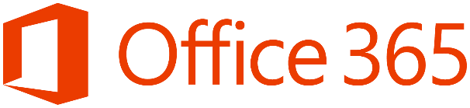

Email Phishing Protection Guide

Introduction: Email Phishing Protection Guide - Enhance Your Organization's Security Posture 2

Part 1: Customize the Office 365 Logon Portal 3

Part 2: Training Users with the Office 365 Attack Simulator 9

Part 3: Deploy Multi Factor Authentication (MFA) 17

Part 4: Deploy Windows Hello 21

Configuration Options for Windows Hello: 22

Group Policy Settings: 22

Microsoft Intune Setup and Settings: 22

User Experience When Setting up Windows Hello: 23

Part 5: Define Country and Region Logon Restrictions for Office 365 and Azure Services 24

Part 6: Deploy Outlook Plug-in to Report Suspicious Emails 32

Install the Microsoft Junk E-Mail Reporting Add-in for Microsoft Outlook (Single Use/Testing) 33

Deploy to all Outlook users: How to administratively deploy the Report Message Add-in to all users 35

Review User Reported Junk and Phishing Email 37

Communicate to Users About Self-Reporting 37

Part 7: Deploy ATP Anti-Phishing Policies 37

Office 365 ATP Anti-Phishing Policies 38

Instructions to Setup Office 365 ATP Anti-Phishing Policies 38

Part 8: Deploy ATP Safe Link Policies 46

Office 365 ATP Safe Links Policies 47

Instructions to Setup Office 365 ATP Safe Links Policies 47

Part 9: Deploy ATP Safe Attachment Policies 49

Office 365 ATP Safe Attachment Policies 50

Instructions to Setup Office 365 ATP Safe Attachment Policies 50

Part 10: Deploy and Enforce Smart Screen for Microsoft Edge, Microsoft Internet Explorer and Google Chrome 52

Windows Defender SmartScreen Group Policy Setup for Microsoft Internet Explorer and Microsoft Edge 53

# **Introduction: Email Phishing Protection Guide - Enhance Your Organization's Security Posture**

Email phishing attacks are a very real concern for every organization. It does not matter who is hosting your email or if you are continuing to host it yourself on-premises, what attackers want now is your user identity. An identity is the username and password that attackers will try every method available to trick a user into providing. Recently I have seen very well-crafted phishing emails that appear to be from someone wanting to connect with me on a social media site to a notification that someone wants to share an online file with me. As a technical person, I like to think I will recognize these fake emails that may occasionally slip through even the best email hygiene filters. But, like everyone else, I realize I am still human and prone to mistakes.

Many of us remember the early days of SPAM emails, specifically those from a certain prince asking for money. Those were the days of people trying to trick you into giving them money. Those types of emails have evolved from years ago into the now far more advanced and targeted phishing email campaigns designed to steal money, download data, cripple an organization, or all three. Recent cyber security reports from [Microsoft](https://www.microsoft.com/en-us/security/intelligence-report), [Verizon](https://www.verizonenterprise.com/verizon-insights-lab/dbir/), and [Cisco](https://www.cisco.com/c/en/us/products/security/security-reports.html), to name just a few, all indicate how wide spread the threat of phishing emails has become. I encourage you to review all three reports that offer in-depth information on cyber security threats seen today across the industry today to understand just how widespread this threat is.

For organizations using Microsoft Office 365, they have some of the best technology available to help defend against these evolving cyber-attacks. I find in many customer conversations that many system administrators, architects, CIOs, etc. are unaware of these options and how they can be used together to increase the security posture of their organization. The solution is to not just put one or two of these items in place, but as many as possible. The more adjustments made to increase your security posture (the more locks you install), the harder it is for the attacker to penetrate your network. Consider the economics of this approach… the more expensive you make it for an attacker to try to penetrate your network, the less likely he or she is to continue the effort.

I have written this multi-part blog series as a guide to deploy and make minor adjustments to several Microsoft Office 365 and Azure services to help further protect your environment from email phishing threats.

I am approaching this series of blogs from a system administrators point of view. In other words, if I were a system administrator using Office 365 what features would I want to implement and adjust to further enhance my organization's security posture and how would I do it? These are only my personal recommendations based on many years of experience and do not represent any type of official recommendations, support, or guarantees from Microsoft.

The first several blogs in this series is about a concept I call the Human Firewall. This concept is about making the phishing email recipient aware of this constant threat and training them to recognize it as a last line of security defence. There are many ways to raise awareness of this growing threat, but even the best awareness training still has a weakness. The human firewall is after all, human. And, the human will make a mistake. So, what are some of the technologies an organization can use to increase the security posture of an environment as well as the human firewall? How can an organization increase its protection from the unsuspecting user 'clicking' on a malicious link?

In addition to blogs that highlight the Human Firewall, additional blogs in this series provide information about how to deploy and adjust several of the features in Microsoft Office 365 and Microsoft Azure to further protect your environment. Defending against phishing emails and other cyber security threats is not just a one solution approach, but rather a variety of solutions to use - many of which are included in the Microsoft Office 365 services organizations already subscribe to. The threat telemetry Microsoft receives throughout its global network of 200+ products is constantly analysed and actioned upon in the [Microsoft Intelligent Security Graph](http://cloud-platform-assets.azurewebsites.net/intelligent-security-graph/). The result is that every organization and every user is protected from these threats. By implementing many of the items in this blog series, security will be increased even more.

At the top of each blog in this series is an index for quick reference. I will continue to create more blogs as this is an ever-evolving threat landscape with new protection features being launched all the time. Please leave any questions, comments, and requests for additional articles at the bottom of each blog.

# Part 1: Customize the Office 365 Logon Portal

As the first part of this blog series with advice about how to enable and adjust features in Microsoft Office 365 to defend against phishing email attacks, we'll start with an element of what I call the Human Firewall. Let's consider this one of the many locks I am highlighting that can be implemented to raise the security posture of your organization.  
Humans are creatures of habit. We don't think much about opening a tablet or laptop to logon with a username/password or using Windows Hello with a fingerprint, facial recognition, etc. We are conditioned to do this each day at the same familiar prompts. With even the slightest change to this conditioned action, we would most likely recognize it and stop. We would stop and consider that something is different, something is not right, and then figure out what it is. This is part of the Human Firewall - making the user stop, think about what he or she is doing, and to be skeptical when things no longer look quite right. Being skeptical is part of an employee awareness program I highlight in the next blog of this guide.

Remember that part of the evolving phishing attacks includes trying to trick your users into providing their username and password in a fake website. These fake websites can look very similar to the real one, fooling even the most skeptical person. If we, as system administrators, change the Microsoft Office 365 logon screen with a customized background and logo, users would be conditioned to seeing this and not think much of it each time they logon. However, they would see a difference in a fake website designed to look like the standard/default Office 365 logon page. This subtle difference is enough to make the user recognize that something is different, determine it is a fake site, and prevent he or she from entering a username and password to an attacker.

I have advised a large number of customers and Microsoft partners to customize their logon portal and have heard from several that users can now easily recognize a fake site. One person shared with me a story of how she was on a phone call in one conversation, Instant Messaging in another conversation, and in another thread responding to an email request from her HR department to update her personal profile online. Even while in the middle of doing these different things, having the company portal customized with their logo was what stopped her from entering logon credentials. After clicking on what seemed like a legitimate email from HR, she was taken to what looked like a normal Office 365 portal, she paused and realized it was a fake site only because she was so used to seeing her company background image and logo on the screen. This is a great example about how our conditioning as humans was interrupted - something was different that makes us stop and analyse the situation. The Human Firewall.

I have outlined the steps below about how you can easily modify your logon site and encourage you to do so. Once customized, be sure to communicate this new screen to all of your users through an internal awareness campaign of emails, lunch and learn sessions, newsletter articles, etc. Make users aware that you are modifying the logon page and why. Reiterate why you are taking this action as part of a security awareness training program. Will this prevent all identities from being stolen? No, but it will certainly help and is one of the many locks you can use to further secure your organization.

**To customize the Microsoft Office 365 logon portal for your organization, follow the steps below:**

1. With a Global Administrator account, logon to <https://portal.azure.com>
2. On the left side of the screen, select *Azure Active Directory*

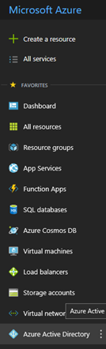

1. Then, select *Company Branding*

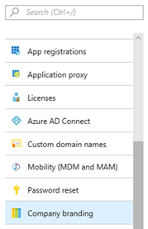

1. With *Company Branding* now selected, the Default profile is displayed to the right. Click *Default* to open the settings.

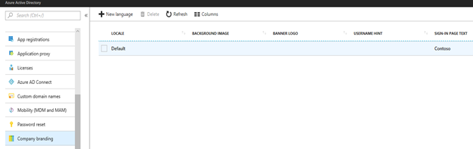

1. Here, you will see the options available to define the background image, your organization's logo, and customized text for the logon screen. When choosing a background image, consider using a picture of your organization headquarters, a picture of a product you make, a picture of the city skyline or downtown that is closest to you. Make it something that is easy to identify and means something to your organization. Make it something that, if it was ever changed, would prompt your users to stop and become skeptical of the logon site.

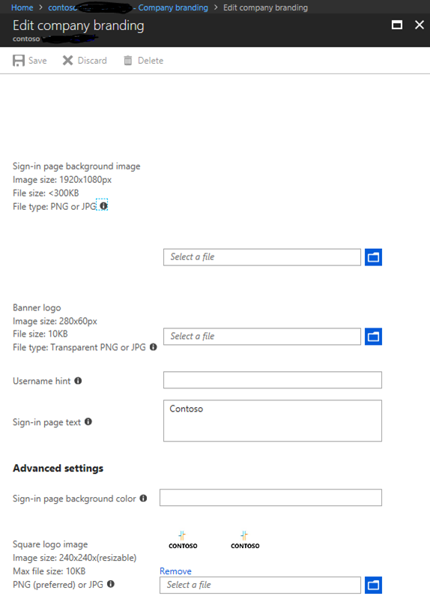

1. As an example, I chose to use a customized background picture I took a few years ago of Waikiki Beach along with the company logo for my demonstration company, Contoso. Note that the pictures you use must follow the file size and type guidelines provided for each field.

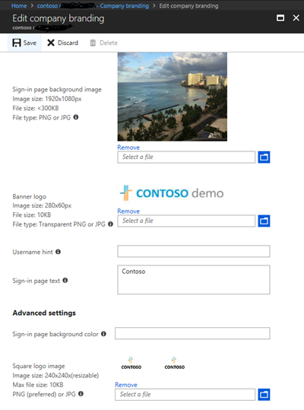

1. When ready, select the *Save* option on the top of the screen. Then, log off of this session and close the browser.

**Note:** In my setup it took about ten minutes for the new background image to appear during logon. Be sure to wait enough time before testing this setting.

1. As you open a new browser to log back in to <https://portal.office.com>, notice that the first logon screen remains the same. Until a username is entered, the system does not know who you are from the millions of other users across the globe. It is only at the second screen where a password is entered that the logon background image and logo has now changed.

*Picture below is of the first logon screen at* [*https://portal.office.com*](https://portal.office.com)

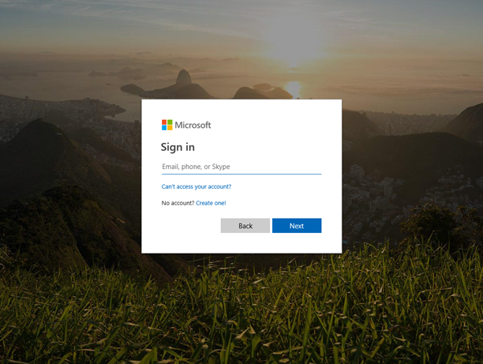

*Picture below is of the second logon screen that is now customized (notice the logo and background image)*

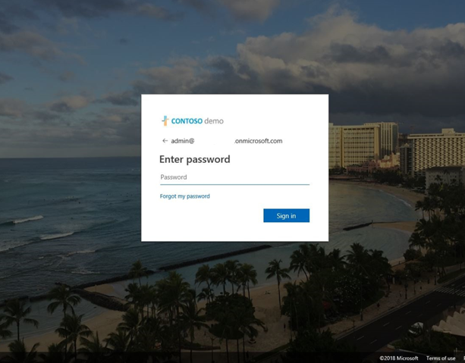

**Conclusion:** Keep in mind that users are often the last line of defence in safeguarding your organization's identities and data. We are all human and mistakes do happen where a user can be tricked into providing his or her credential to an attacker. Since there is no technology by any vendor(s) who will provide 100% security on your network, we are often left with only the Human Firewall standing in the way. The more ways you can raise awareness and strengthen your Human Firewall, the more protected you and your organization will be.

# Part 2: Training Users with the Office 365 Attack Simulator

This is the second part in a blog series of steps about how you can use many features within Microsoft Office 365 to protect your users and environment from the constant onslaught of identity phishing attacks. In this blog we will continue to focus on what I call the Human Firewall and how to train it - adding another lock an attacker will need to overcome. Even with the best technology and network defences in place, there is no strategy that will provide 100% cyber security for your network. At the end of the day the user can be the weakest link and therefore must be trained to help identify and avoid threats that may make it past even the most robust cyber security environment.

With an organization's users often being the last line of defence, they must constantly be trained to recognize and report threats when seen. When a phishing email makes its way into the network, it should never be the first time a user has seen such a well-crafted email. Rather, the user must be well trained to recognize the real from the fake emails. In March 2018, Microsoft released the Office 365 Attack Simulator Tool. At launch, the tool provided several great tools to simulate phishing attacks, launch brute force password attacks as well as to launch password spray attacks. In this blog I focus on the phishing attack simulator part of the tool.

As a way to keep the user environment constantly trained and to quickly identify suspicious email, be sure to include this tool in your cyber security awareness training program. This tool should not be used once, but on a regular basis to a rotating group of users. In this blog, I provide a series of steps to setup and create your first email phishing attack, along with where to find a large number of examples to use.

Once you have tested and feel comfortable using the phishing attack simulator, you will then want to design several simulations you can launch on a routine basis. The more thought you put into the design and the more real they appear to users, the better the user training will be and the stronger the Human Firewall will become. For ideas to use for developing your own phishing campaigns, I wrote a separate blog series with ten or more examples located [here](https://blogs.technet.microsoft.com/cloudready/2018/04/30/phishing-examples-for-the-microsoft-office-365-attack-simulator-part-one/).

**To setup a simulated phishing campaign using the Office 365 Attack Simulator, follow the steps below:**

1. Login to [https://portal.office.com](https://portal.office.com/) with your global administrator account. Remember to customize this portal as highlighted in Part 1 of this blog series.  
   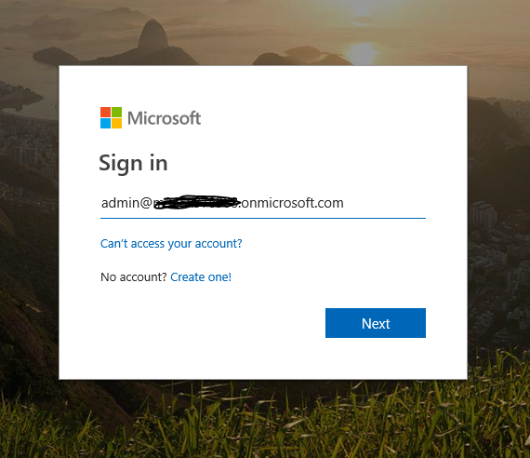  
   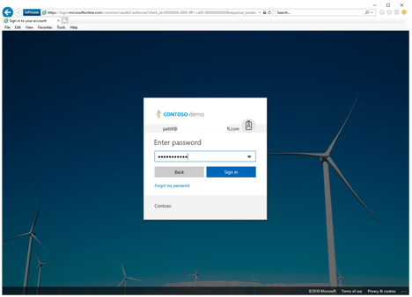
2. Click on the *Security and Compliance* option

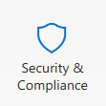

1. Within the Security & Compliance portal, expand *Threat Management*. Then select *Attack Simulator.*

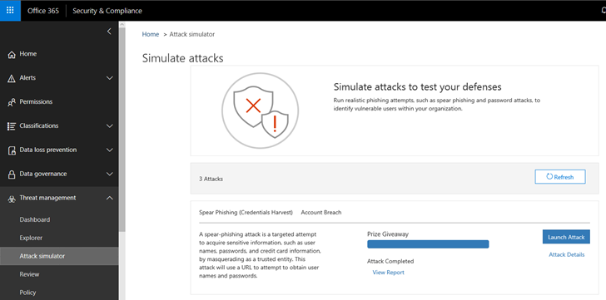

1. You may see a warning in the middle of the screen above that says, "You must enable Multi-Factor Authentication (MFA) to schedule or terminate attacks." As the warning indicates, the account you are logged in with must have MFA enabled before you can setup and launch a simulated phishing attack. If you need to set this up, follow the steps in Part 3 of this blog series.



1. Assuming you do not see the warning above, let's define our first phishing attack simulation. Click on the *Launch Attack* option below.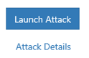
2. Start by naming your new phishing simulation campaign. For example, "First Annual Company Retreat."  
     
   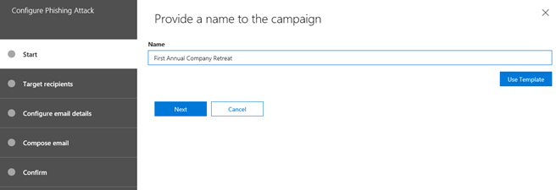
3. Next, address the phishing simulation to several TEST accounts. The accounts shown below are fictitious as part of a demonstration environment I am using. I do not recommend using real user accounts to test with. Click *Next* when ready.
4. 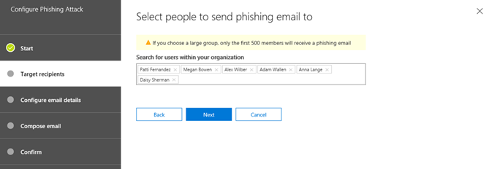Define the parameters shown. As your first test, use the information provided in the fields below.

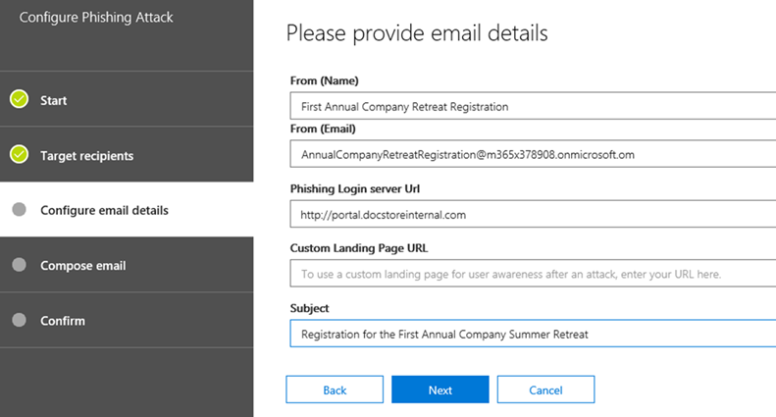

1. Define the body of the email below. This example can be copied from the blog examples I wrote in a blog series [here](https://blogs.technet.microsoft.com/cloudready/2018/04/30/phishing-examples-for-the-microsoft-office-365-attack-simulator-part-two/).

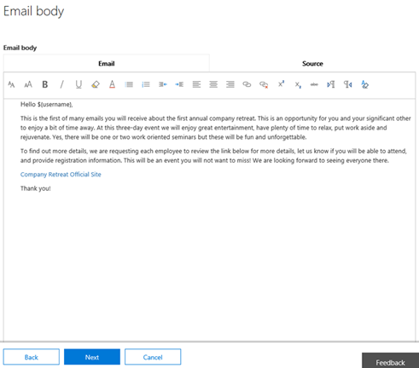

1. With the parameters chosen, select *Finish* to launch the attack.

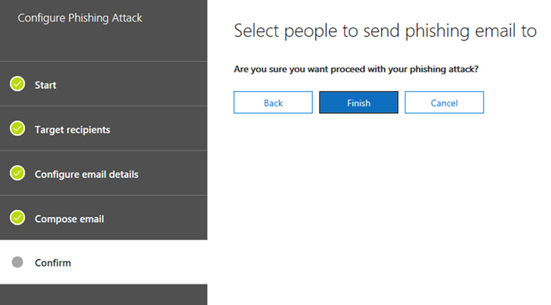

1. To test the phishing simulation, open an In-Private session in your web browser and logon to <https://portal.office.com> as the test recipient user account.

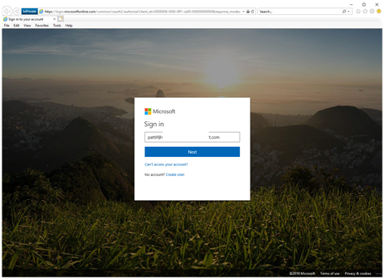  
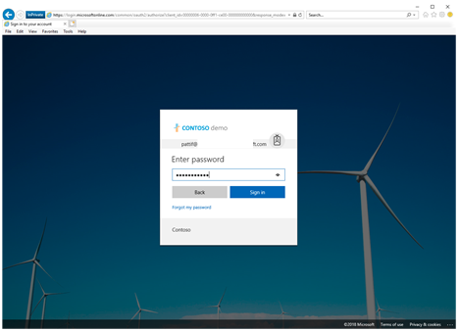

12. Make sure the phishing email was received. Then, click on the link and logon to the simulated phishing site.

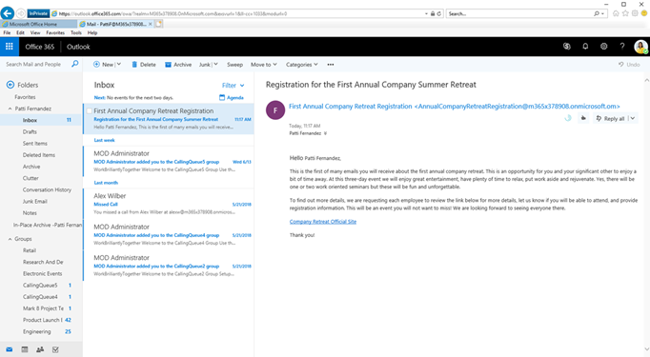

13. Once complete with a logon to the simulated phishing site as the test user, the screen below is seen indicating this was part of a phishing simulation. This site is customizable so an organization can design their own page with links to required training.

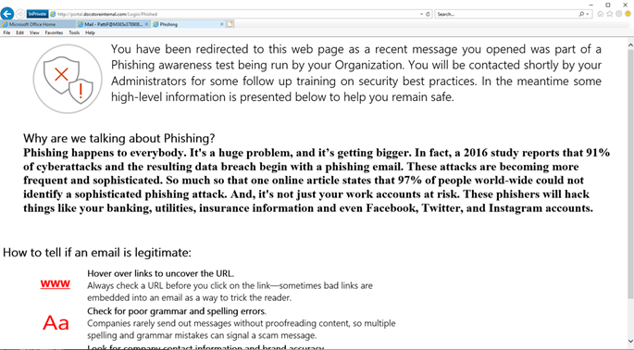

14. With the phishing simulation completed, we can now look at the results of the test. Back in the Attack Simulator, the attack is listed as *Completed* with a new option to *View Report*.

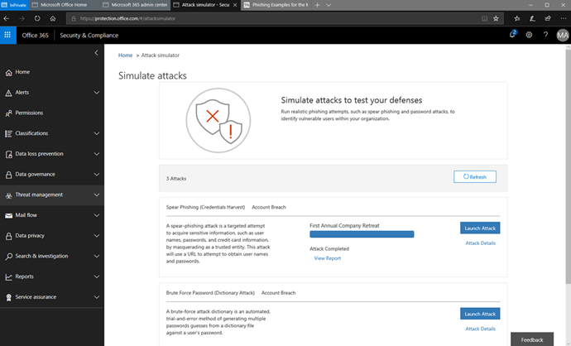

15. Here, we can see exactly which recipients clicked on the link and that they entered their credentials, indicating a successfully phished user. Having a list of users may be used to indicate how much of a real problem this is in your environment and how detrimental this type of phishing attack could have been if real. It also can help with justification to design, fund, and launch a periodic phishing awareness campaign.

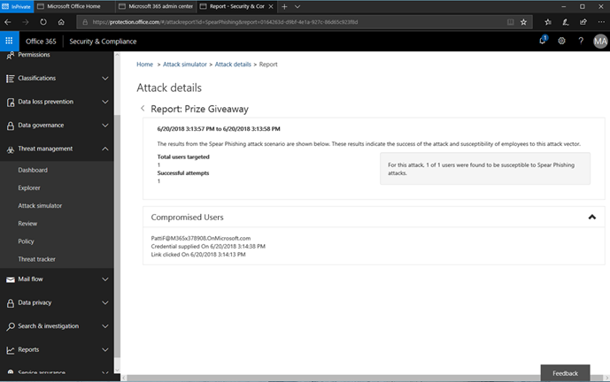

**Conclusion:** Training all users in your organization to be skeptical of emails in their Inbox needs to be part of every cyber security awareness training. The Office 365 Attack Simulator is a great tool to use to help increase user awareness about phishing emails and help to fortify the Human Firewall.

# Part 3: Deploy Multi Factor Authentication (MFA)

This blog series highlights and explains how to setup the many features in Microsoft Office 365 to protect your users and environment from the constant onslaught of identity email phishing attacks. This is part three of the blog series where I will continue to focus on what I call the Human Firewall and start to look at technology you can enable to provide further protection to your environment. Let's now look to setup another lock in your organization to keep the attackers out.

Enabling Multi-Factor Authentication (MFA) can be one of the quickest and most impactful ways to protect the identities of your users. This feature has been available for all Office 365 users since February 2014 ([announcement](https://www.microsoft.com/en-us/microsoft-365/blog/2014/02/10/multi-factor-authentication-for-office-365/)), but I find it concerning to discover system administrators have not enabled it for their users. I hear comments that MFA makes accessing accounts difficult for users, it is too complicated, there is user training involved, or those who question its effectiveness. I need to stress the threat of identity theft for all user identities is very real and the primary goal of most email phishing attacks. The attackers do not care how small or large an organization is or what cloud provider is being used, a stolen user identity to access vital information is invaluable. Consider the recent security reports from [Microsoft](https://www.microsoft.com/en-us/security/intelligence-report), [Verizon](https://www.verizonenterprise.com/verizon-insights-lab/dbir/), and [Cisco](https://www.cisco.com/c/en/us/products/security/security-reports.html) that all indicate the scale and growing threat of email phishing attacks.

When setup properly, MFA is hardly noticeable to users in any organization. Certainly, you don't want to have an MFA prompt every time a user checks email on a smartphone or logs into <https://portal.office.com> from a company owned device that is either in an office or joined to Azure Active Directory (AAD). But you do want to have a user prompted for MFA where it makes sense such as when logging on to Office 365 services from a Bring Your Own Device (BYOD) like a tablet or a home computer. An organization's system administrator or security team has no idea what condition BYOD devices are in and what malware may be on them, requiring the need for an increase in identity protection. The goal is to protect the data and user identity on trusted and untrusted devices and implementing MFA is one of the strongest locks available. For more information on planning for MFA in Office 365, please review this [link](https://support.office.com/en-us/article/Plan-for-multi-factor-authentication-for-Office-365-Deployments-043807b2-21db-4d5c-b430-c8a6dee0e6ba).

Considering the Human Firewall element of identity protection after reviewing Part 1 and Part 2 in this blog series, what happens when a phishing email does arrive in the Inbox of a user? The phishing email could be very well crafted to trick even the most skeptical and well-trained eyes. Consider now that the user clicks on the URL in the phishing email and enters his or her credentials. Without MFA enabled, the attacker has achieved the initial goal of acquiring credentials and will start to work his/her way through the profile and move on to other credential harvesting methods from the inside. But with MFA enabled, at logon to the Office 365 portal using the stolen credentials the attacker will be challenged for the additional account verification. Depending on how MFA was setup, this could be with a temporary access code sent to the user's cell phone or a phone call, a smart card, a biometric device, etc. With MFA, the attacker would be prevented from accessing the user's data and causing a major security breach in your organization.

Consider that while many phishing emails are sent in a blanket approach, many are now using an attack method called spear phishing. This is a targeted phishing campaign at, for example, the leadership team of an organization who may have financial authority to approve wire transfers or access to sensitive data. Or, as another example, it could be spear phishing emails targeted at the technical team with administrator access. It doesn't take much effort to search public social media sites to figure out who is part of a leadership or technical team at most organizations. That attackers are smart, motivated, and should never be underestimated.

Take an immediate step to help secure your organization by enabling MFA for anyone with the Global Administrator role in Office 365. Then push to enable MFA for the leadership team who are often heavily targeted by phishing emails. Finally, deploy MFA to all user accounts. There is a [new baseline protection policy](https://docs.microsoft.com/en-us/azure/active-directory/active-directory-conditional-access-baseline-protection) now in preview (July 2018) in Office 365 that can be set to force MFA for anyone with the Global Administrator access. The same policy can be extended for groups in your organization such as for the leadership team. Remember to carefully plan your deployment of MFA as well as a well-thought out communications and cyber security awareness training plan for your organization.

**How to Enable Multi-Factor Authentication on an Account in Office 365**

1. Logon to <https://portal.office.com> with a Global Administrator account. Select *Users*. Then select the *More* option. Next, click on the *Multifactor Authentication* setup.

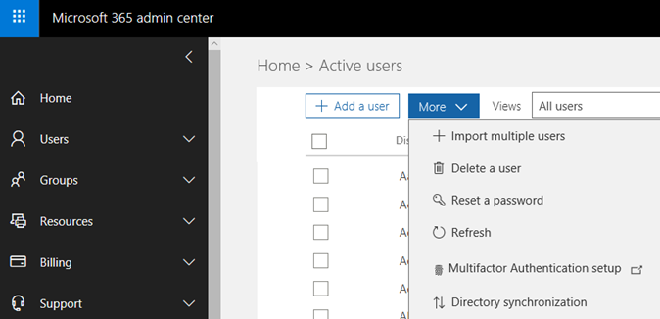

1. In the *Multi-Factor Authentication* page, locate your Global Administrator account and place a check mark next to the name to enable the account for MFA.

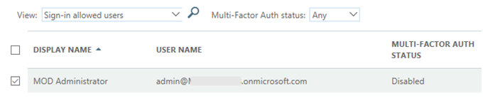

1. A warning about enabling Multi Factor Authentication will appear. When ready, select the *Enable Multi-Factor Auth* option to continue.

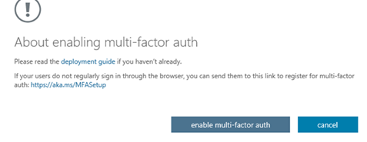

1. A confirmation screen will then appear.

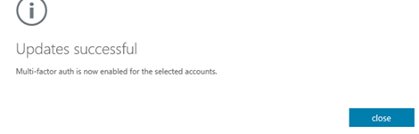

1. Sign out of the account, close the browser, and then sign back in again. This time, you will be prompted to setup MFA for the account.

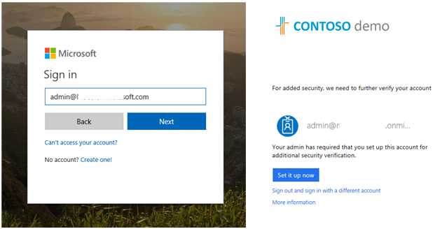

1. Select how the service should contact you for MFA challenge.

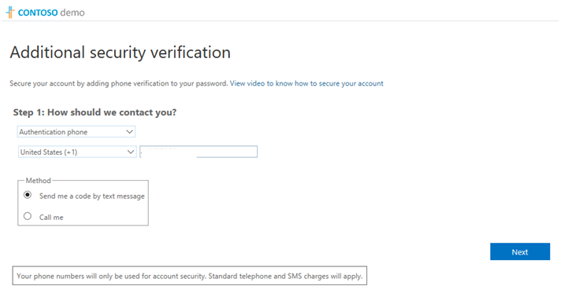

1. If you chose the text authentication method, a code will then be sent to your device to use.

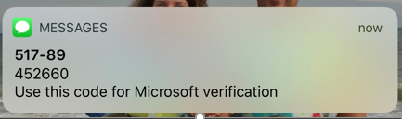

1. Enter the code into the next screen to complete the authentication.

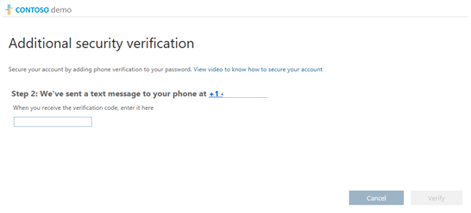

1. The setup for MFA is now complete.

**Conclusion:** In this blog I reviewed how important it is to enable MFA on accounts in Office 365 to secure user identities. I also walked through the very quick and simple setup of MFA on accounts. Remember to plan the implementation according to guidance provided by Microsoft including testing and communicating the change with users in the organization.

# Part 4: Deploy Windows Hello

This blog series highlights and explains how to setup the many features in Microsoft Office 365 to protect your users and environment from the constant onslaught of identity email phishing attacks. This is part four of the blog series where I move away from the Human Firewall and more into the technology that should be configured to provide additional protection for your organization. Windows Hello is a feature included in Windows 8, 8.1, and 10 that is another lock to implement in you organization to keep the attackers out.

As discussed in earlier blogs in this series, phishing attacks are designed to steal a username and password - the identity of users. The attacker can then use these credentials to gain access to organizational data and launch additional attacks from. But what if we removed the username and password from a user and provided another, more secure method to logon? Instead of a username and password, what about a quicker method the user would prefer to logon with each day? Without entering a username and password to steal, an email phishing attack is useless. Using Windows Hello, this is possible by enabling a long using a PIN, fingerprint, or facial recognition. At this point you may be wondering how a PIN used with Windows Hello is any better than a password because both could be stolen and used. With Windows Hello, the PIN is tied to only the specific device it was setup on. So if a Windows Hello PIN was stolen it is of no use to an attacker as it can't be used from another system to logon with. For more information, be sure to review this link: [Why a PIN is Better Than a Password](https://docs.microsoft.com/en-us/windows/security/identity-protection/hello-for-business/hello-why-pin-is-better-than-password).

I recommend you review the information about Windows Hello in [this](https://docs.microsoft.com/en-us/windows/security/identity-protection/hello-for-business/hello-overview) site for deeper technical information on this great feature - my intent in this blog is not to re-iterate the information already available in the provided link. Rather, the intent of this blog to create awareness in its capabilities to help thwart identity theft from phishing emails. Keep in mind that Windows Hello is based on strong two-factor authentication on PCs and mobile devices. As outlined in [this](https://docs.microsoft.com/en-us/windows/security/identity-protection/hello-for-business/hello-overview) document about Windows Hello, "Authentication is the two-factor authentication with the combination of a key or certificate tied to a device and something that the person knows (a PIN) or something that the person is (Windows Hello)." For user devices where a username and password is still being used, a periodic password change will not impact this process ([reference](https://docs.microsoft.com/en-us/windows/security/identity-protection/hello-for-business/hello-and-password-changes)).

When talking with customers about this great way to provide a quick and secure authentication method for their environment, I sometimes hear concern regarding where a person's facial imprint or fingerprint is stored. This is a common and great question that I am happy to answer. As stated [here](https://docs.microsoft.com/en-us/windows/security/identity-protection/hello-for-business/hello-biometrics-in-enterprise), the gesture used in Windows Hello (fingerprint or facial imprint) is only stored on the device and is never shared with an external server or cloud system. As part of a communication plan when enabling this feature in your organization, be sure to include information about this topic. Encourage your users to embrace this technology for faster and more convenient logons, as well as a way to further help secure the environment. Address the privacy concerns to make them feel secure and comfortable using it.

There is no shortage of devices available on the market that support Windows Hello. This could be a laptop with an integrated fingerprint reader, or a webcam designed for Windows Hello. A list of integrated devices that support Windows Hello is available [here](https://www.microsoft.com/en-us/windows/view-all-devices?col=windowshello). For devices that do not have a biometric device included, the PIN option is available as well as external USB connected fingerprint readers and external Windows Hello compatible cameras. Coming soon (limited private preview April 2018), FIDO2 Security keys will enable users to carry their credential with them to safely authenticate to Azure AD joined Windows 10 pcs ([video](https://www.youtube.com/watch?v=f9lqFsWiyPg&feature=youtu.be)). Imagine the convenience and security this new key will provide to a hospital where pcs are shared by doctors, nurses, and other personnel each day. Also [announced](https://blogs.windows.com/msedgedev/2018/07/30/introducing-web-authentication-microsoft-edge/) in July 2018 is the capability to use Windows Hello in Microsoft Edge, providing a more secure and password-less web browsing experience.

Fast, Easy, and a Secure Sign on - each and every day. This is how I logon each day, without a username and password and I love it. To understand more about how Microsoft is enabling users like myself to leave usernames and passwords in the past, see the blog post with embedded videos called [Building a World Without Passwords](https://cloudblogs.microsoft.com/microsoftsecure/2018/05/01/building-a-world-without-passwords/). As part of a plan to help increase the security posture of your organization and limit the threats of email phishing, consider enabling Windows Hello as another security lock.

## Configuration Options for Windows Hello:

Windows Hello may be applied using a Group policy setting, using a Mobile Device Management (MDM) policy in Microsoft Intune as well as Configuration Manager. The Windows Hello for Business Deployment Guide available [here](https://docs.microsoft.com/en-us/windows/security/identity-protection/hello-for-business/hello-deployment-guide) provides detailed configuration steps, so I am not going to rehash them here. Also included in the guide are the prerequisites for the configuration to work correctly.

In addition to the deployment guide link above, I have provided high level information below for accessing and configuring each option.

## Group Policy Settings:

* Each of the Group Policy settings available for configuration is available in [this](https://docs.microsoft.com/en-us/windows/security/identity-protection/hello-for-business/hello-manage-in-organization) article.
* Settings are configured by opening the Group Policy Editor and expanding either the User or Computer Configuration -> Policies -> Administrative Templates -> Windows Components -> Windows Hello for Business
* Once the policy is setup, apply it to your target group
* I recommend setting this up in a test lab first so you can test your settings and become comfortable with the behaviour. If needed, setup a 30 day Microsoft Intune free trial at this [site](https://docs.microsoft.com/en-us/intune/free-trial-sign-up).

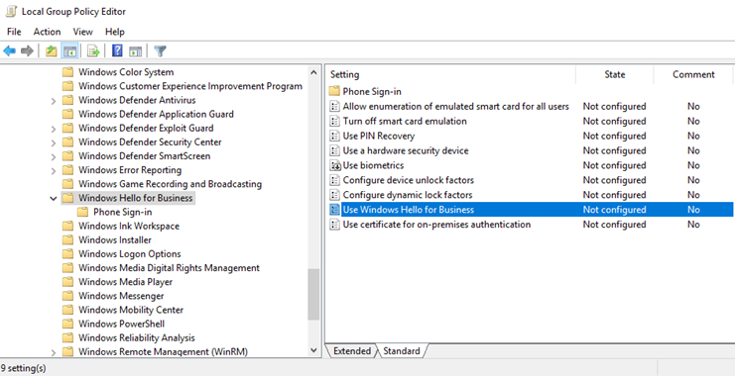

## Microsoft Intune Setup and Settings:

Microsoft Intune may be used to enforce Windows Hello for Business.

1. The configuration options are accessed below by signing in with a global admin account to <https://portal.azure.com>. From there, search for *Microsoft Intune*. From within Microsoft Intune, select Device enrollment, *Windows Enrollment*, and then *Windows Hello for Business*.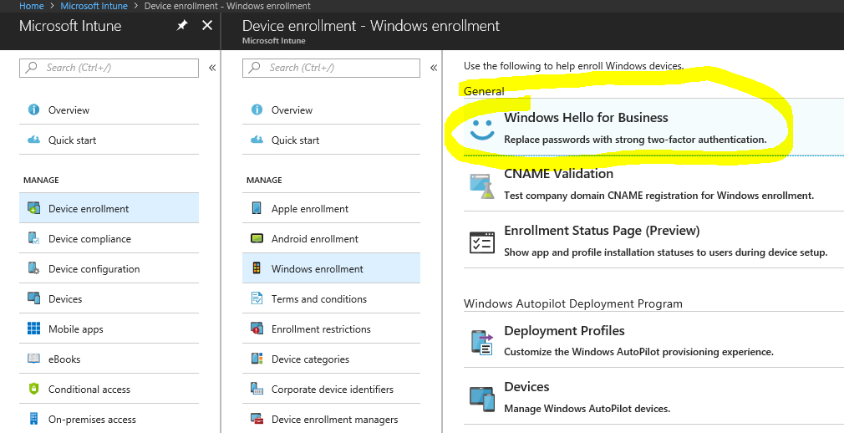.
2. With *Windows Hello for Business* selected, highlight the *Default* policy below. Then select *Settings*. To view the configuration options below, change the top option *Configure Windows Hello for Business* to *Enabled*.

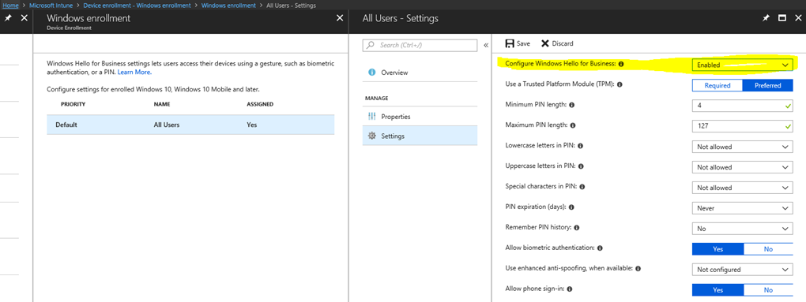

## User Experience When Setting up Windows Hello:

To learn more about the user experience to setup Windows Hello, see this [blog](https://blogs.windows.com/windowsexperience/2016/10/31/windows-10-tip-how-to-set-up-windows-hello-on-your-pc/). This post will allow users to see if their device works with Windows Hello and how to set up facial recognition, fingerprints, and a PIN.

**Conclusion:** Part 4 of this blog series highlights the security benefits of using Windows Hello. By removing the need for usernames and passwords and instead using Windows Hello, an email phishing attack designed to steal identities is rendered useless. This is a feature that, when enabled, users will want to use each day to logon, if anything out of convenience over the standard username and password method.

# Part 5: Define Country and Region Logon Restrictions for Office 365 and Azure Services

We are on a journey in this series of blogs to increase the security posture of your organization against phishing emails. We are setting up a variety of locks that an attacker will need to pick, limiting the chances of a security breach from an email phishing attack. In this next blog I discuss a feature in Azure Active Directory called Conditional Access that has several capabilities, including a way to permit a logon from only the countries or regions where your organization operates.

From a security perspective, being able to define who can access an organization's resources by countries or regions is another way you can further enhance the security posture of an organization. If a user receives a well-crafted phishing email, clicks on the malicious link, and then provides his or her Office 365 credentials, the attacker would normally be able to logon to the account (assuming other controls are not in place) from anywhere in the world. However, let's consider that you are the administrator to a small doctor's office in North Dakota, USA and you have implemented a Conditional Access policy that limits access only from locations in the United States and Canada. If the attacker tried to logon with the stolen identity from anywhere other than these two defined countries, the access would be blocked - protecting the valuable and sensitive information at the doctor office.

For organizations with users who do not travel out of their home country, this is a straight forward policy to configure. Generally, for small to mid-size organizations you can define geographic regions your users are most likely to logon from. For larger organizations, you may need to be more selective in the countries you select as acceptable logon locations. For organizations that are continuing to expand into new areas, this may not be a static list of countries. Rather, acceptable logon locations should be reviewed on a frequent basis to balance access for traveling users conducting business and protecting the organization from external threats.

Keep in mind that this is not a perfect solution, but rather another lock an attacker trying to steal identities will need to pick through. In our doctor office scenario above of only allowing logons from the United States and Canada, this policy will prevent an attacker external of these locations from directly logging into the site. However, a sophisticated attacker may have access to remote systems in these countries with which they can logon from. It is the quantity of strategic locks you implement in your organization that prevent attacks from being successful.

For more information about creating Location Conditions in a Conditional Access policy, see this [link](https://docs.microsoft.com/en-us/azure/active-directory/active-directory-conditional-access-locations).

**Caution:** Before you proceed with the steps in this document, you must set this up first in a lab environment to verify intended behaviour. A misconfigured access rule in a production environment could prevent access to business users. Be sure you have researched, tested, and piloted these steps before proceeding into production.

**Below are steps about how to setup Conditional Access to restrict logons by geographic regions:**

1. Logon to [https://portal.azure.com](https://portal.azure.com/) with an account assigned to the Global Administrator role.

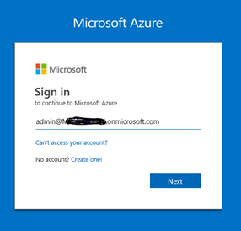

1. Enter the password.

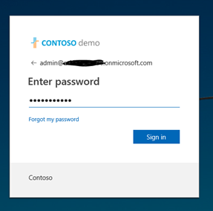

1. When logged into the Microsoft Azure portal, click on *Azure Directory* on the lower left. Then, scroll down the options and select *Conditional Access*.

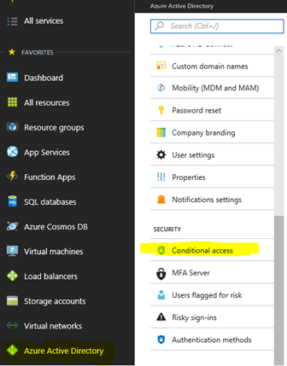

1. In the Conditional Access configuration area, we will first define the locations for trusted access. Select *Named Locations*. Then select *+New Location*.

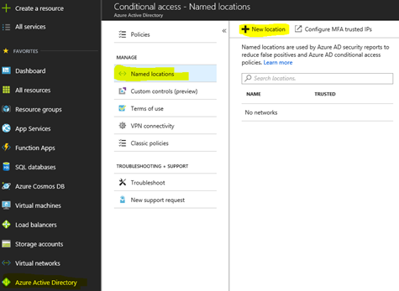

1. Give your location a new name. In my example, I defined *United States and Canada Only*. Then select *Countries/Regions* and choose these two countries in our example.

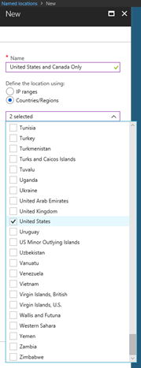

1. With the two countries selected, I also chose to *Include Unknown Areas* as well using the option below.

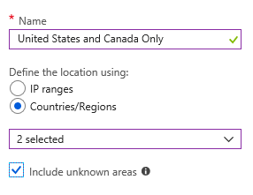

1. When ready with your selections, choose to *Create* the new location with the Create option at the bottom of the screen.



1. The new location is now defined as shown below.

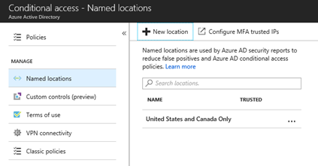

1. With a Named Location now defined, we can setup a policy to use it. Select *Policies* at the top left of the screen.
2. Select *New Policy*

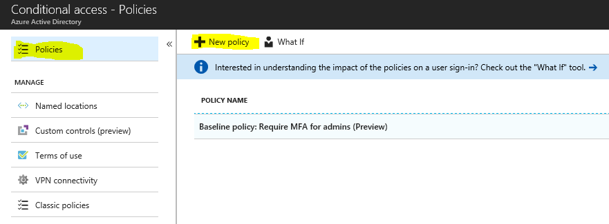

1. Within the new policy, create a name. For this example, I called mine *Trusted Logon Location*. Then select *Conditions*, and then *Locations*.

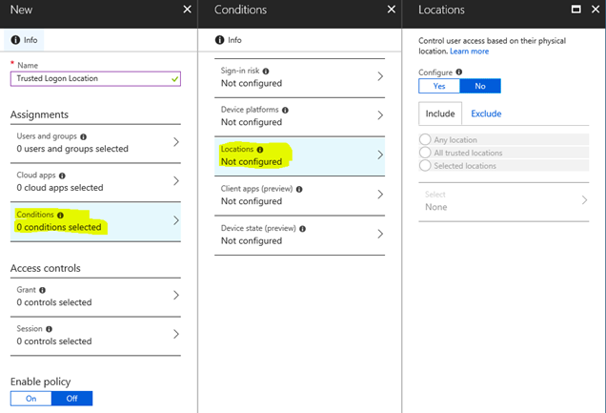

1. Select *Yes* to *Configure* the location on the right of the screen. Select the *Any Locations* option.

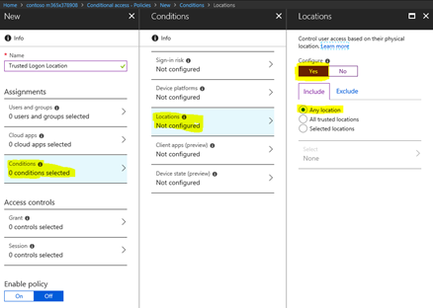

1. Next, select the *Exclude* tab as highlighted below. Choose the option for *Selected Locations*. Highlight the *Select* option and place a check in the boxes next to *MFA Trusted IPs* and *United States and Canada Only*.

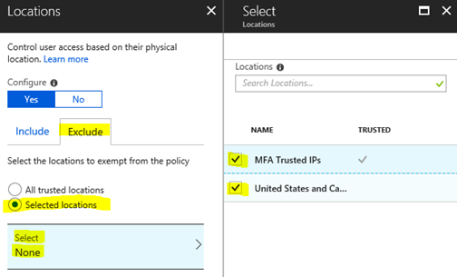

1. At the bottom of the screen, click *Select* to save the settings. Then select *Done* to close Locations and select *Done* to Save Conditions. Finally, choose to enable the policy by selecting *On*.

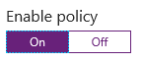

1. Back in the policy creation area, notice that you can now Enable the policy, but that *Create* at the bottom is not an option to finalize the policy. We still need to define an Access Control.

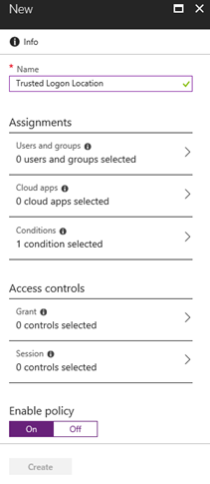

1. Under the Access Controls section, select *Grant*.

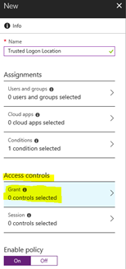

1. Then select the option to *Block Access*. Click *Select* at the bottom to define the policy.

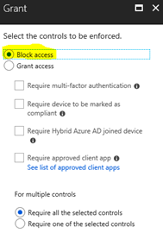

1. **Caution**: Before proceeding, be sure you have tested these steps in a demo environment and that you understand the intended behaviour. A failure to correctly configure this rule could prevent you from accessing your own organization.

Notice at the bottom of the new Conditional Access policy that the Create option is now available. Select the *On* option and then click *Create* to enable the policy.

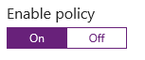



1. Log out of the browser and close the session. Allow several minutes for the rule to apply, then open a new browser session and logon to verify access.

**Conclusion**: In this blog we have reviewed one of the areas of a Conditional Access policy we can define to prevent logons to Office 365 or Azure services from countries or regions outside of where your organization operates. While this is another lock to protect from phishing attackers using stolen identities, it is not perfect. More advanced attackers could remote control systems inside the countries and regions you have defined for access to work around this policy.

# Part 6: Deploy Outlook Plug-in to Report Suspicious Emails

This blog series highlights and explains how to setup the many features in Microsoft Office 365 to protect your users and environment from the constant onslaught of identity email phishing attacks. This is part six of the blog series where I review an option that enables users to help protect the environment. By providing a quick and easy way for users to report SPAM and malicious phishing emails they receive and identify, your users can become your best allies in security. By using the Outlook Add-In for reporting unsolicited or malicious emails your users can help enhance the filtering capabilities of the Office 365 systems. Thus, adding strength to another security lock to keep your organization safe.

The SPAM filtration along with the many other security services in Office 365 are unmatched in the industry, offering users the best protection available. But, from time to time a message may slip through that should have been identified as malicious, SPAM, etc. and blocked. As a system administrator, the question becomes how do you enable your users to easily report these emails to the Office 365 analysis services?

This blog describes how you can publish an Outlook add-in (no cost) to the Outlook ribbon for users to simply highlight the email, classify it as Junk, SPAM, or a phishing email, and submit. It doesn't get any easier than this! I recommend this add-in be installed with Outlook to each user along with how and why to use it. By submitting emails like this for analysis, the filtration system learns about new attacks and becomes much better to protect all of us. Below are instructions about how to install the add-in on a user workstation to test with, how to administratively install it across all accounts in your Office 365 tenant, as well as how to then monitor for Junk and Phishing messages that have been submitted.

Although this blog is focused on the Outlook Add-in for reporting SPAM, other useful Add-ins should also be considered for installation such as Translator and Weather. There are hundreds of additional add-ins available for Outlook to review and choose from that may be perfect to enhance the security and productivity for your organization!

Additional information about how to submit SPAM, non-spam, and phishing scam messages for analysis are available in this [Link](https://technet.microsoft.com/en-us/library/jj200769(v=exchg.150).aspx).

## Install the Microsoft Junk E-Mail Reporting Add-in for Microsoft Outlook (Single Use/Testing)

**Option One:** Download and Install

1. Download the Add-In from this [site](https://www.microsoft.com/en-us/download/details.aspx?id=18275)
2. Choose the correct version to download (32-bit or 64-bit)
3. Save the download and install it using a few quick steps in the wizard

**Option Two:** Install from Microsoft Office Store

1. With Microsoft Outlook open, look in the ribbon bar at the top for an option called *Store* in the Add-ins category.

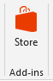

1. Click on the *Store* icon. In the Search add-ins area, enter *report message* and press enter.
2. Locate the *Report Message* add-in and click *Add*.

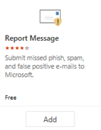

1. This should take only a few seconds to install. When complete, you may click on the option to *Get Started* for a brief tutorial in how to use it or click *X* to close this area.

**Using the Outlook Add-in:**

1. The new Report Message Add-in will now be visible in the Outlook ribbon bar to begin using no matter what method of installation you chose above.

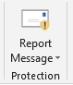

1. Locate a SPAM message in your Inbox, highlight it, then click on the Report Message drop down option to select if it is *Junk* or a *Phishing* message.

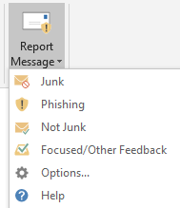

1. After the *Junk* or *Phishing* classification is chosen, you will see the message below indicating that the email submission is processing.



1. Within a few seconds the email will be submitted and removed automatically from the Inbox.
2. You may receive a notice with a definition of what Phishing email is and asking you if you "*want to send a copy of this message to Microsoft to help the research and improvement of email protection technologies?*" Click on *Report* to submit.
3. To prevent the notice from appearing each time the user submits a SPAM message, the user can click the Report Message Add-in drop down option and select *Options*.
4. Within the *Options* area, the user can select to *Automatically send reports* that will prevent a prompt for each submission.

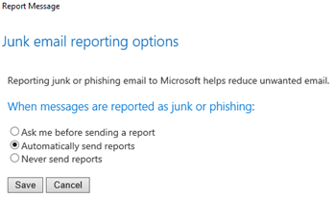

1. Select *Save* to save the changes and exit.

## Deploy to all Outlook users: How to administratively deploy the Report Message Add-in to all users

1. Logon to the Office 365 Administrator portal at portal.office.com
2. Under *Admin Centers*, open *Exchange*.

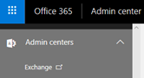

1. In the *Exchange Admin Center*, select *Organization* on the left.
2. Then, choose *Add-ins.*
3. In the Add-ins area, you will see several pre-defined items already listed.
4. To choose a new Add-in, click the **+** icon.
5. Then select to *Add from the Office Store*

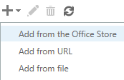

1. In the new website that was just opened, the view is focused on only *Add-ins for Outlook.* In the upper right, locate the *Search the Office Store* area. Enter *Report Message* and press *Enter*.
2. The Report Message app is now displayed. Click on it to view the details.

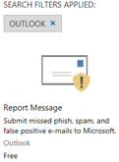

1. In the details of the Add-in, select *Add* to include it as an Administratively assigned Add-in for your tenant users.

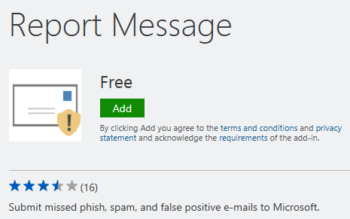

1. Confirm that you want to Add the Add-in by clicking *Yes* on the notice.
2. Once you receive the message that *You've added an Add-in for Outlook*, open the tab with the Exchange Admin Add-ins area displayed you were just on.
3. Select the *Refresh* icon (highlighted below) to verify that the *Report Message* add-in is now displayed.

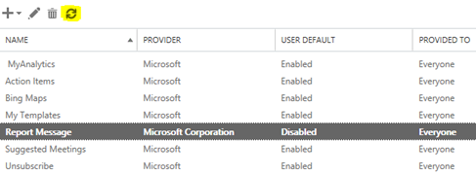

1. You will now see that *Report Message* add-in is listed. But wait! It is *Disabled* by default. Let's correct that now so users will be able to see and begin using it.
2. In the Add-in list, double click on the *Report Message* area to open the detailed configuration.
3. Select the option to be *Optional, enabled by default*. Click *Save* to complete this step.
4. The list of Add-ins will now show the *Report Message* Add-in displayed as *Enabled* under the User Default column.

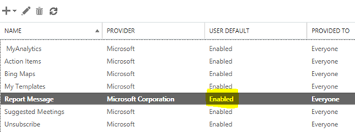

1. Once complete, the *Report Message* Add-in (or any other Add-in) may take a few hours to appear. In my test, it took about two hours for my Outlook client to show the *Report Message* Add-in. (deployed at 2:31pm 4/2)

## Review User Reported Junk and Phishing Email

As a network administrator you always want to keep your finger on the pulse of your organization to understand just how users are utilizing the services. Now that you have enabled users to report their own junk and phishing emails, you will want to make sure they are using this option. Use the option below to access this area.

1. Logon to <https://portal.office.com>
2. Open the *Security and Compliance* dashboard
3. Under *Threat Management* (left column area), choose the *Dashboard* option
4. In this area, look for the section called *User-Reported Messages*. Click on it to see the number of messages submitted per day, who is submitting, the email subject, sender, sender IP and type of message reported (junk or phishing)

## Communicate to Users About Self-Reporting

With this Outlook Add-in now enabled, be sure to communicate its existence and capabilities to your Outlook users. With a few simple steps in the instructions (and screen captures), your users will be able to report any Junk and Phishing emails they receive. The more SPAM, malicious, and phishing email messages submitted, the better the services become for everyone!

**Conclusion:** In this blog I reviewed the Outlook Add-in called Report Message that is available in all Office 365 organizations. We walked through several options to install it as a single instance as well as for all users in the organizations. Also included are steps about how to submit these unwanted emails and then monitor the submissions in the reporting area of the Office 365 portal.

# Part 7: Deploy ATP Anti-Phishing Policies

We are on a journey in this series of blogs to increase the security posture of your organization against phishing emails. We are setting up a variety of locks that an attacker will need to pick for a successful email phishing attack. So let's consider that a well-crafted phishing email has managed to pick through a few locks and made it to a user's email Inbox. Given the potential that the user may now click on the phishing link (or an attachment), we want to setup another "lock" to help prevent any type of malicious activity as a result. ATP Anti-Phishing Policies, ATP Safe Links, and ATP Safe Attachments (security features within Office 365 ATP) can help protect environments from a user who may unknowingly click on a malicious link or attachment.

I have encountered several organizations who have been the targets of spear phishing attacks. This is when specific users in an organization are the targets of a sophisticated phishing campaign designed to steal their logon credentials. These targeted users are often those people on the leadership team of an organization, most often those with some type of financial authority who can wire transfer money. Once the identity of these individuals are stolen, an attacker then has the keys to work through your organization.

This blog series has outlined several padlocks an attacker must pick to steal user identities. As another padlock, we will define and enable Office 365 ATP Anti-Phishing policies to help prevent these emails from being delivered.

## Office 365 ATP Anti-Phishing Policies

As explained in this [link](https://support.office.com/en-us/article/atp-anti-phishing-capabilities-in-office-365-5076d0f6-7a59-4d6c-bd07-ba95033f0682?ui=en-US&rs=en-US&ad=US), "ATP anti-phishing applies a set of machine learning models together with impersonation detection algorithms on incoming messages to provide protection from commodity and spear phishing attacks." Organizations that have ATP capabilities in their Office 365 subscriptions must define ATP anti-phishing policies. Also explained in the aforementioned link(see example scenarios), this policy is not defined or active by default. It is up to the organization to define policies based on their internal design.

With Office 365 anti-phishing policies in place, incoming messages are evaluated for many items including impersonation of users and/or other domains. Machine learning models help to determine phishing messages and what is the appropriate action by policy to take.

## Instructions to Setup Office 365 ATP Anti-Phishing Policies

Note: Only user accounts in your organization with the ATP license assigned to their account will be protected by this policy. Please see the section how to How to Get ATP Anti-Phishing in this [link](https://support.office.com/en-us/article/atp-anti-phishing-capabilities-in-office-365-5076d0f6-7a59-4d6c-bd07-ba95033f0682?ui=en-US&rs=en-US&ad=US) for licensing information.

1. Logon to <https://protection.office.com> as a global administrator in your Office 365 tenant. This opens the *Security & Compliance* area of the tenant.
2. Within the *Security & Compliance* area, expand *Threat Management* and then click on *Policy*.

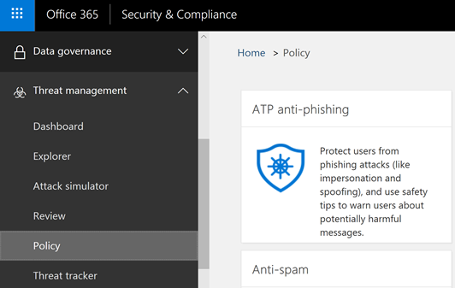

1. Click on the *ATP Anti-Phishing* tile.
2. Notice that within the Anti-Phishing policy administration area how there are no policies defined by default.

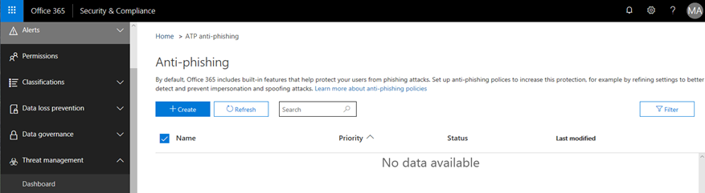

1. Create a new policy by clicking on the *+Create* option.

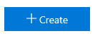

1. Start by providing a name for your new policy. For this example, we will setup a policy to be applied to an organization's leadership team - this team of people are often the targets of spear-phishing attacks. The policy will be named *Leadership Team Phishing Policy*. The description is *Policy used to protect against spear phishing attacks target at the Leadership Team. Applied July 29, 2018 by KM. Change Ticket #32987*. For testing purposes, I recommend setting up a policy on a few technical users in your organization who I like to call *friendlies*. Click *Next* when ready.

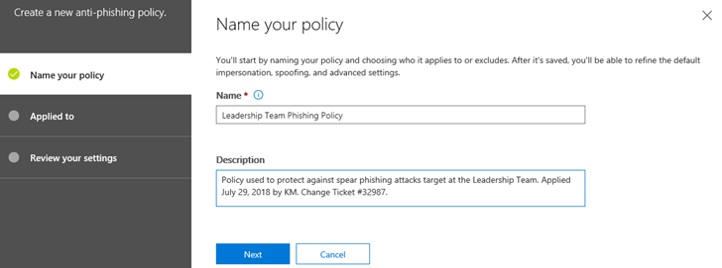

1. There are a number of conditional options to be defined that are described in detail in a table [here](https://support.office.com/en-us/article/set-up-office-365-atp-anti-phishing-policies-5a6f2d7f-d998-4f31-b4f5-f7cbf6f38578?ui=en-US&rs=en-US&ad=US). For this example policy, the following conditions will be applied:

a. *Applied To*: Select the user names in your environment to apply the policy too. As you begin to type in each user's name, Office 365 will resolve to that name. Notice what happens when I enter MeganB, a user in this demonstration environment - the name resolves where it can then be selected. You could also add these users to a group and define the group name here instead (for example, a Leadership Team email distribution list). Click *Next* after entering one or more names.

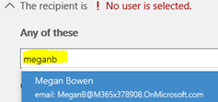

b. The next screen displays a summary of your settings to review and edit if needed. Click on *Create This Policy* when ready.

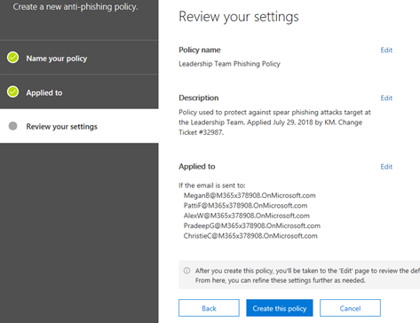

8. In the next screen we have options in the policy that must now be edited to make sure it behaves as needed.

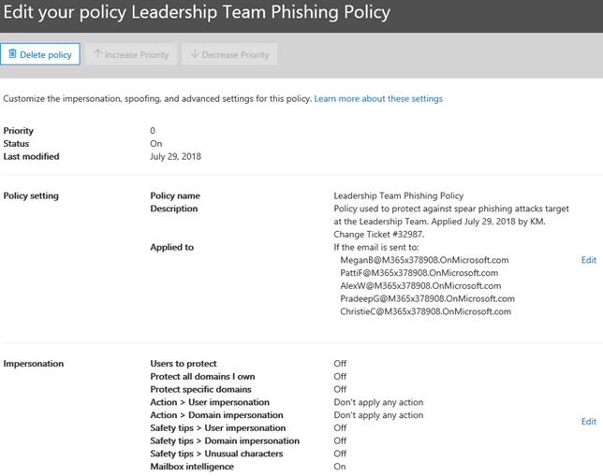

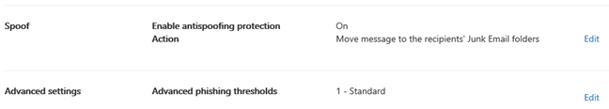

9. In step 7, we already created basic options in the policy setting. Now we will define advanced options under *Impersonation*. Click on the *Edit* option to the right of this section.

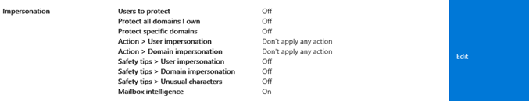

10. In the first screen under *Edit Impersonation Policy*, select the option to turn *ON* the policy. Next, select *Add User*.

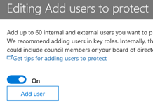

11. Add each user where this setting will be applied. Similar to when the policy was created in an earlier step, you may enter a user name or email address to add each person. Do NOT click *Save* when done as this will exit from the *Edit Impersonation Policy* area. Rather, click on the next item in the list to edit - *Add Domains to Protect*.

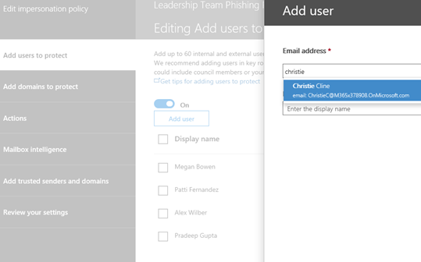

12. In the next area, *Add Domains to Protect*, select the option to enable *Automatically Include the Domains I Own*. Next, click *Actions* (do not select *Save* yet.)

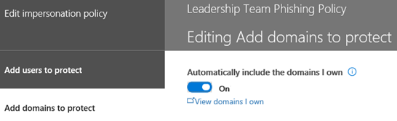

13. In the Actions area, select the option of your choice for *If email is sent by an impersonated user*. If I were administering a network, my selection would be to *Quarantine the Message* so the user would not see it even in their Junk Email folder. I want to filter these messages to keep users from accidently clicking on phishing links no matter what folder they are in.

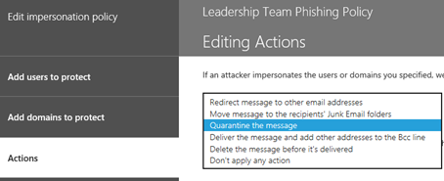

In the Actions area, under the second option If email is sent by an impersonated domain, I would choose the same option to *Quarantine the message*.

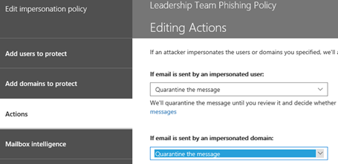

Note: These settings should be carefully decided and defined for what is appropriate for your organization.

14. Click *Mailbox Intelligence* next (do not click *Save* yet). Mailbox Intelligence is already *On* by default, so no changes are needed in this section. Click *Add trusted senders and domains*.

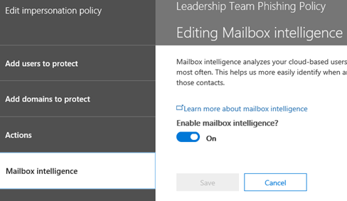

15. In *Added trusted senders and domains*, I will not include a value in this example. You may want to consider adding a partner organization you work with often to this area.

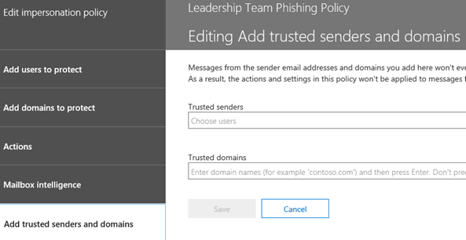

16. Click *Review your settings*. In the screen below, you may review your settings again. Click *Save* when done to save the new *Leadership Team Phishing Policy*.

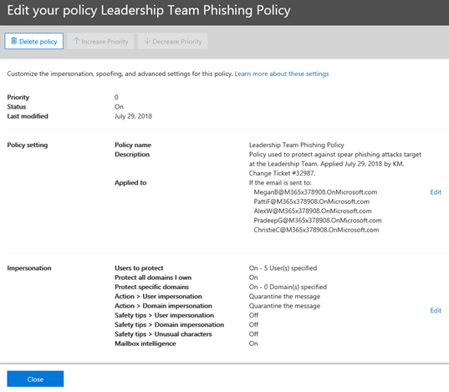

17. Click *Close* to exit the policy creation area. The policy is now active on the users defined. Remember, these users must also have the correct Office 365 ATP license defined to work correctly.

18. Back in the *ATP anti-phishing* panel, verify the policy is enabled under the *Status* area.

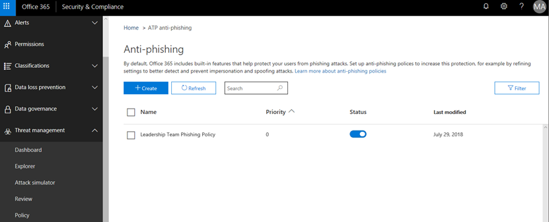

19. The Office 365 ATP Anti-Phishing policy is now active in your environment. With this policy in place, be sure to monitor for any messages captured and placed into quarantine. Part 11 in this blog series discusses the monitoring console in detail.

20. Back in the *Security & Compliance* area, expand *Threat Management*. Then, click *Threat Tracker* to view items in quarantine. In addition to this blog about configuring ATP Anti-Phishing, be sure to review the other options to further secure your environment.

**Conclusion:** In this blog we reviewed ATP Anti-Phishing policies and how to implement and then monitor them for intended behaviour.

# Part 8: Deploy ATP Safe Link Policies

We are on a journey in this series of blogs to increase the security posture of your organization against phishing emails. We are setting up a variety of locks that an attacker will need to pick for a successful email phishing attack. Organizations need to make it as difficult as possible for an attacker to be successful. So, let's consider that a well-crafted phishing email has managed to pick through a few locks and made it to a user's email Inbox. Given the potential that the user may now click on the phishing link (or an attachment), we want to setup another lock to help prevent any type of malicious activity as a result. ATP Anti-Phishing Policies, ATP Safe Links and ATP Safe Attachments (security features within Office 365 ATP) can help protect environments from when a user may unknowingly click on a malicious link.

Hyper-links included in any inbound message to Office 365 email users are rewritten when Safe Links is enabled, and policies are defined. This feature also extends to email sent from one Office 365 user to another either within the same tenant or to another tenant. In early 2018, the URL protection was also extended to Office 365 documents that are stored in Word Online, Excel Online, PowerPoint Online, and OneNote Online (as well as Office 365 ProPlus on Mac) - providing a much greater layer of protection across an organization. As explained in this [link](https://support.office.com/en-us/article/Office-365-ATP-safe-links-dd6a1fef-ec4a-4cf4-a25a-bb591c5811e3), "ATP Safe Links can help protect your organization by providing time-of-click verification of web addresses (URLs) in email messages and Office documents." If a link is scanned and found to contain malicious content, instead of opening, the user will presented with a warning page instead ([examples of warning page](https://support.office.com/en-us/article/office-365-atp-safe-links-warning-pages-fc4e6ebb-5acc-4bc5-bad8-4f3407d1d3f4?ui=en-US&rs=en-US&ad=US)). Office 365 ATP Safe Links provides another layer of locks in the email and Office Online environment that every organization should consider implementing. See the section in this [link](https://support.office.com/en-us/article/Office-365-ATP-safe-links-dd6a1fef-ec4a-4cf4-a25a-bb591c5811e3) called *How do we get ATP Safe Links protection* if not already included in your Office 365 subscription.

## Office 365 ATP Safe Links Policies

Organizations that have ATP capabilities in their Office 365 subscriptions must define policies for ATP Safe Links. Also explained in the link (see the table on example scenarios), this policy is not defined or active by default. It is up to the organization to define policies based on their internal design.

## Instructions to Setup Office 365 ATP Safe Links Policies

Note: Only user accounts in your organization with the ATP license will be protected by this policy. Please see the section how to How to Get ATP Safe Links in this [link](https://support.office.com/en-us/article/atp-anti-phishing-capabilities-in-office-365-5076d0f6-7a59-4d6c-bd07-ba95033f0682?ui=en-US&rs=en-US&ad=US) for licensing information.

1. Logon to <https://protection.office.com> as a global administrator in your Office 365 tenant. This opens the *Security & Compliance* area of the tenant.
2. Within the *Security & Compliance* area, expand *Threat Management* and then click on *Policy*.

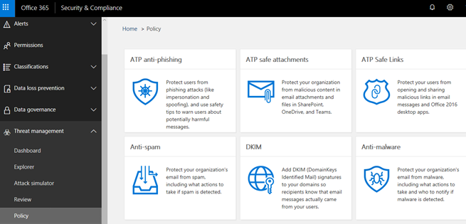

1. Click on the *ATP Safe Links* tile.
2. In the *Safe Links* area is a policy called *Default*. Let's edit it to include several monitoring features. With *Default* highlighted, click on the *pencil* icon to edit it.

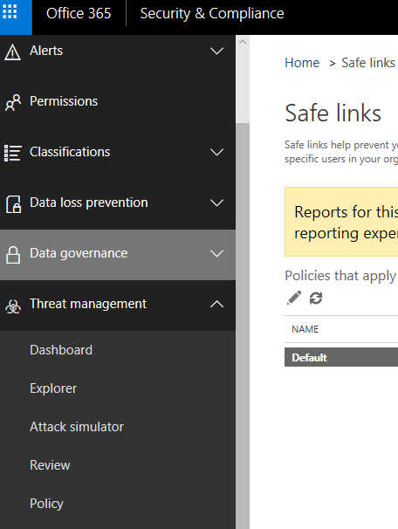

1. Within the Default policy, I recommend the following options be set to increase the security of these areas.

*Use Safe Links in:*

*Office 365 ProPlus, Office for iOS and Android:* ***Enabled***

*Office Online of above applications:* ***Enabled***

*For the locations selected above:*

*Do not track when users click on safe links:* ***Disabled*** (Note: If it were my organization to administer, I would want to see if I have a problem with users clicking on links. This could indicate a need for additional training to recognize phishing emails.)

*Do not let users click through safe links to original URL:* ***Enabled*** (Note: The goal is to prevent the unsuspecting user from clicking on a malicious link. This is where they should be blocked.)

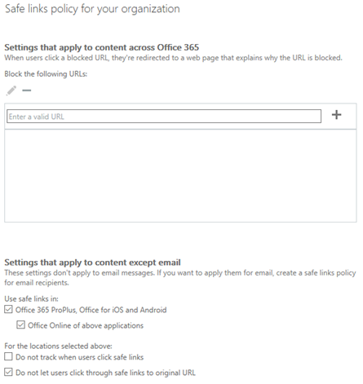

1. Click *Save* when done with the settings. With these settings in place, you now want to monitor the quarantine area of your environment.
2. Back in the *Security & Compliance* area, expand *Threat Management*. Then, click *Threat Tracker* to view items in quarantine. In addition to this blog about configuring ATP Safe Links, be sure to review the other options to further secure your environment.

**Conclusion:** In this blog on ATP Safe Links we reviewed how this feature helps to further secure an organization and how to define a protection policy. We also reviewed how to monitor the quarantine area in Threat Tracker.

# Part 9: Deploy ATP Safe Attachment Policies

We are on a journey in this series of blogs to increase the security posture of your organization against phishing emails. We are setting up a variety of locks that an attacker will need to pick for a successful email phishing attack. An organization needs to make it as difficult as possible for an attacker to be successful. So, let's consider that a well-crafted email with an attachment has managed to pick through a few locks and made it to a user's email Inbox. Given the potential that the user may now open the attachment, we want to setup another lock to intercept and scan the document for any malicious payloads. ATP Safe Attachment Policies (one of several security features within Office 365 ATP) will help protect organizations from users who unknowingly open an attachment with a malicious payload.

With Office 365 ATP Safe Attachments, when a user receives an email with a file attached and clicks on it to open, the attachment is first opened and tested for malicious payloads in a virtual environment before being released to the user. If the attachment is safe, it will then open for the user. However, if it was found to contain malicious content the attachment is removed from the email and a warning message is displayed. This same type of protection is now available in documents that may be stored in SharePoint or OneDrive in the formats for Word Online, Excel Online, PowerPoint Online, and OneNote Online (as well as Office 365 ProPlus on Mac) - providing a much greater grid of protection in your organization. Office 365 ATP Safe Attachments provides another layer of formidable locks in the email and Office Online environment that every organization should consider implementing. See the section in this [link](https://support.office.com/en-us/article/office-365-atp-safe-attachments-6e13311e-92ae-495e-a619-56d770199170?ui=en-US&rs=en-US&ad=US) called *How to get ATP Safe Attachments* if not already included in your Office 365 subscription.

## Office 365 ATP Safe Attachment Policies

Organizations that have ATP capabilities in their Office 365 subscriptions must define policies for ATP Safe Attachments. Also explained in earlier links (see the table on example scenarios), the ATP Safe Attachment policy is not defined or active by default - even with the licensing assigned to users. It is up to the organization to define policies based on their internal design.

### Instructions to Setup Office 365 ATP Safe Attachment Policies

Note: Only user accounts in your organization assigned with the ATP license will be protected by this policy.

1. Logon to <https://protection.office.com> as a global administrator in your Office 365 tenant. This opens the *Security & Compliance* area of the tenant.
2. Within the *Security & Compliance* area, expand *Threat Management* and then click on *Policy*.



1. Click the *ATP Safe Attachments* tile. Notice in this area that the option to enable the feature is not enabled by default.

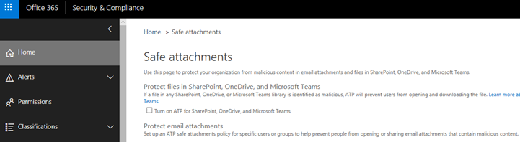

1. Click on the option to *Turn on ATP for SharePoint, OneDrive, and Microsoft Teams*.



1. Click on the option to create a new policy for email protection. Click on the addition symbol.



1. In the configuration window that appears, I recommend the following settings.

a.  Start by giving your policy a new name. I called mine *Email Safe Attachment Policy* for this example.

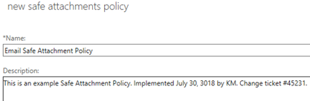

b.  In the bottom option of this screen, notice the default action of *Off*. If it was my organization, I would choose the *Replace* option. This option makes sure there is no chance the user will receive the attachment and launches it before being scanned for malicious content. As always, be sure to evaluate all options for the one that fits best in your organization.

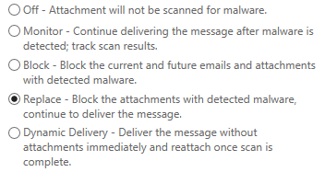

c.  In the *Redirect Attachment on Detection* area, define an email address to redirect any of the attachments found to be malicious. This email address must first be created in the admin console. You may want to look into a [Microsoft Flow](https://flow.microsoft.com/en-us/) or some other notification rule that is sent to a monitored Inbox (your account or a support team) indicating that malicious content has been detected, blocked, and forwarded to the email account specified that may be unmonitored. If you do not choose this option, you will receive several warnings indicating email could be lost.

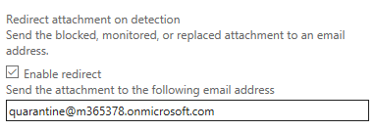

d.  In the *Applied To* section, in the drop-down area I recommend choosing *The Recipient Domain Is* option, so the policy is applied to all users in your organization. In the example below, I have defined my demo domain.

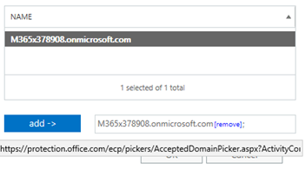

e.  Click *OK* when done and then *Save* to complete the configuration. Be sure to click *Save* at the bottom of the configuration changes to activate this policy.

1. Back in the *Security & Compliance* area, expand *Threat Management*. Then, click *Threat Tracker* to view items in quarantine. In addition to this blog about configuring ATP Safe Attachments, be sure to review the other options to further secure your environment.

**Conclusion:** In this blog on ATP Safe Attachments we reviewed how this feature helps to further secure an organization and how to define a protection policy. We also reviewed how to monitor the quarantine area in Threat Tracker.

# Part 10: Deploy and Enforce Smart Screen for Microsoft Edge, Microsoft Internet Explorer and Google Chrome

Within this blog series we are setting up a variety of locks that a phishing attack will need to pick for a successful email phishing attack. The previous blog in this series discusses how to configure ATP Safe Links, ATP Safe Attachments, and ATP Anti-Phishing policies (features within Office 365 ATP) to protect links in email and Office files in Office 365. But we need to also consider another phishing attack vector. Suppose a user is checking his or her private email account in an Internet browser installed on your organization's equipment. The user's personal email may contain malicious phishing links, that once clicked, will install malware to devices within your organization. Instead of clicking on a phishing link, suppose the user is searching the web and clicks on a website that attempts to install malware on your organization's device in what we call a drive-by infection. Let's walk through how we can setup another padlock of protection against these scenarios.

Internet Explorer and Microsoft Edge have long had a feature called SmartScreen available to protect web surfers from malicious links. In April 2018, the protection scanning capability in these two browsers was made available in a Google Chrome extension called Windows Defender Browser Protection. By defining an Active Directory Group Policy Object (GPO), we can deploy and define these security settings in the environment (i.e. prevent a user from disabling the protection). We can also use a GPO to deploy the extension to Google Chrome to users. Below are steps about how to setup the GPO and deploy it. I highly recommend this first be done in a lab environment to verify settings and intended behaviour.

Before we move on with the deployment steps, I encourage you to learn more about the great capabilities of SmartScreen and how it can protect your users from malicious sites that can install drive-by malware infections (including protection from zero-day attacks).

* [Evolving Microsoft SmartScreen to Protect You from Drive-By Attacks](https://blogs.windows.com/msedgedev/2015/12/16/smartscreen-drive-by-improvements/)
* [Windows Defender Smart Screen Group Policy and Mobile Device Management Settings](https://docs.microsoft.com/en-us/windows/security/threat-protection/windows-defender-smartscreen/windows-defender-smartscreen-available-settings)
* [What is Microsoft SmartScreen?](https://support.microsoft.com/en-us/help/17443/windows-internet-explorer-smartscreen-filter-faq)

Optional configuration and deployment settings are listed below for Microsoft Internet Explorer, Microsoft Edge, and Google Chrome. To further secure the environment, you may want to consider limiting the use of browsers in your organization to only those with these types of enhanced security features.

With today's ever evolving threats we all need to be vigilant and increase our organization security posture using a variety of advanced features (the goal of this blog series). The goal being, to add as many locks as possible in an organization without impacting user productivity. The security of your organization is only as good as the weakest link which is often the unsuspecting user.

## Windows Defender SmartScreen Group Policy Setup for Microsoft Internet Explorer and Microsoft Edge

1. Download the Microsoft Windows 10 ADMX files to expose the Microsoft Internet Explorer and Microsoft Edge settings to configure in a GPO. The latest ADMX files for Windows 7, 8.1, and 10 are located in [this site](https://support.microsoft.com/en-us/help/3087759/how-to-create-and-manage-the-central-store-for-group-policy-administra). Also included are instructions about how to manage the Central Store for Group Policy Administration.
2. Install the downloaded file to your client. By default, the new ADMX files will be located in *c:\Program Files (x86)\Microsoft Group Policy\Windows 10 April 2018 Update (1803) v2\Policy Definitions*.
3. Within the folder above:

a. Locate the *Windows.admx* and *Edge.admx* file and copy it to %logonserver%\sysvol\yourdomainname\Policies\PolicyDefinitions. If *PolicyDefinitions* does not exist, create it.

b. Enter the language folder you will be using in the environment to locate the *Windows.adml* and *Edge.adml* file. For my lab environment, I will be using English, so I opened the *EN-US* folder to locate the *Windows.adml* and *Edge.adml* files. Copy this file to %logonserver%\sysvol\yourdomainname\Policies\PolicyDefinitions. If you need multiple languages, be sure to copy additional *Windows.adml* and *Edge.adml* files as well.

1. Configure Internet Explorer settings for Windows Defender SmartScreen:

If it was my organization to manage from a technical security point of view (this is my personal opinion), my recommendation would be to enable each of these policies to prevent users from installing applications that are not in the Windows Store as well as to prevent users from bypassing SmartScreen Warnings. These settings may vary based on your organization and technical governance. There is always a balance between too much technical control in the name of security and a negative impact to business productivity, so be sure to discuss these settings with your organization.

There are several settings to review in this area I have highlighted below. When you open each item, there is a detailed description of what each setting does.

* *Prevent bypassing SmartScreen Filter warnings: Enabled*
* *Prevent managing the phishing filter: Enabled*
* *Prevent managing SmartScreen filter: Enabled*

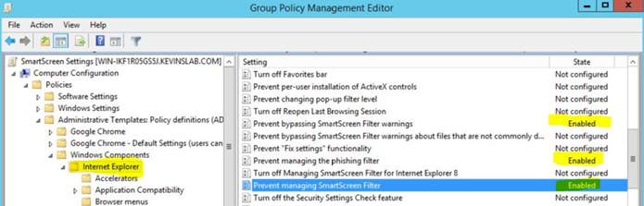

      5. Configure Microsoft Edge for Windows Defender SmartScreen

Similar to the settings for Internet Explorer, there are several areas for the Microsoft Edge policy to configure.

* *Configure Windows Defender SmartScreen: Enabled*
* *Prevent bypassing Windows Defender SmartScreen prompts for sites: Enabled*

For the same reasons above, I have enabled these policies to help protect an organization from users who may unknowingly click on malicious sites. Again, please evaluate these settings for proper usage in your organization.

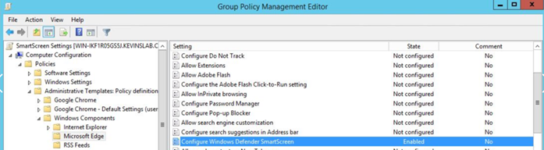

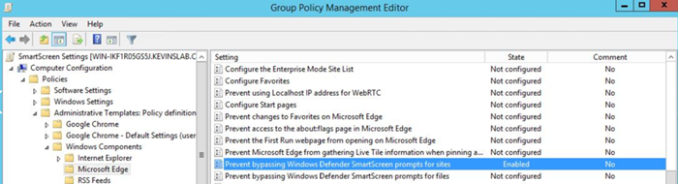

6.  With the policies defined I am ready to assign the GPO to a pilot user(s). Before we assign the policy, let's first verify the user ability to disable SmartScreen in Microsoft Internet Explorer and Microsoft Edge with the steps below.

**Microsoft Internet Explorer**

* Open Internet Explorer and click on the *Gear icon* as highlighted below
* Click *Safety*
* Notice the option to *Turn off Windows Defender SmartScreen* is available to the user.

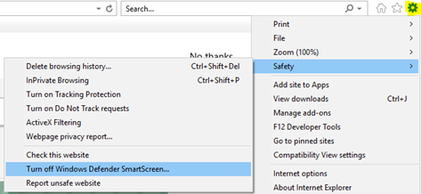

**Microsoft Edge**

* Click on the menu option in the browser *(…)*
* Click on *Settings*
* Under *Advanced Settings*, click on *View Advanced Settings*

At the bottom of the screen, verify the option *Help protect me from malicious sites and downloads with Windows Defender SmartScreen* is not disabled/greyed-out.

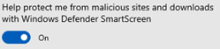

7.  In the new *SmartScreen Settings* GPO, I created an Active Directory Users Group called *SmartScreenPilot* and added a test user to it. From there, I defined the group in the *Security Filtering* area and added the target computer account as well.

8. To force the new GPO to install, I opened a Command Prompt and ran the command *gpupdate /force* command.

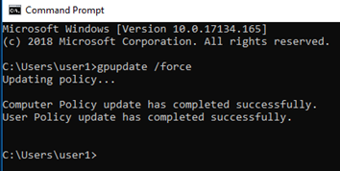

9. Verify the policy is now in place for Microsoft Internet Explorer and Microsoft Edge with the steps below.

**Microsoft Internet Explorer**

* Open Internet Explorer and click on the *Gear* icon as highlighted below
* Click on *Safety*
* Notice the option to *Turn off Windows Defender SmartScreen* is now disabled/greyed-out

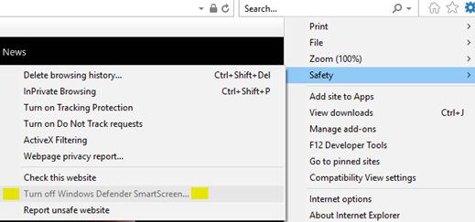

**Microsoft Edge**

* Click on the menu option in the browser *(…)*
* Click on *Settings*
* Under *Advanced Settings*, click on *View Advanced Settings*
* At the bottom of the screen, verify the option *Help protect me from malicious sites and downloads with Windows Defender SmartScreen* is now disabled/greyed-out

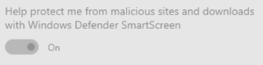

10.  To verify the settings are working:

* In each browser visit the site: <https://demo.smartscreen.msft.net/>
* Then click on each option to see the result

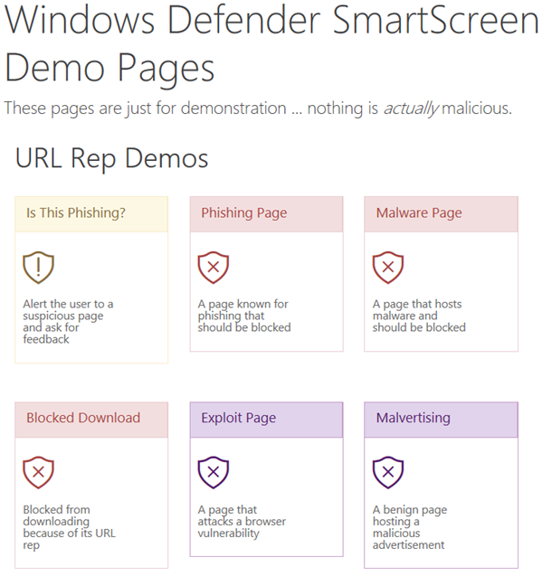

**Windows Defender Browser Protection Extension for Google Chrome**

This extension enables you to use the intelligent SmartScreen capabilities found in the Microsoft Edge and Internet Explorer browsers on Google Chrome as an extension called Windows Defender Browser Protection. Remember the breadth of the [Microsoft Security Story](https://www.microsoft.com/en-us/security/default.aspx) and the vast array of intelligence analysed for malicious behaviour that is then used to protect all of us. This same protection now extends into the Chrome browser and in turn, helps to protect your organization.

**Note:** In the Internet Explorer and Edge browsers there are controls in place to prevent users from disabling SmartScreen. While this protection can be deployed to Google Chrome in the Windows Defender Browser Protection extension, there is no capability to prevent users from disabling it or removing it. In my view, I'd rather have the ability to provide further default protection in the Chrome browser than not, even if a user could disable it at a later time.

This extension can be enabled installed using two methods:

1.  The first is to open the Chrome web store and search for *Windows Defender Browser Protection* extension. From there, you can install the extension. The extension can be found in [this site](https://chrome.google.com/webstore/detail/windows-defender-browser/bkbeeeffjjeopflfhgeknacdieedcoml) with additional information to review. This is useful for testing or single instance installations. I have included installation instructions below.

2.  The second option is to deploy this extension remotely to a large group of users. While I have already outlined information above for how to deploy the plug in using a GPO, I have provided information in the next section about how to install this remotely to all users in your organization. Installation instructions below.

**Installing Windows Defender Browser Protection for Google Chrome for a Single User**

1. From within Google chrome, go to <https://chrome.google.com/webstore/category/extensions?hl=en>
2. In the Chrome Web Store search area, enter *Microsoft Defender Browser*.

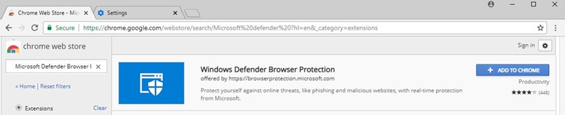

1. Click the button to *Add to Chrome*

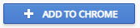

1. Click the option to *Add Extension*

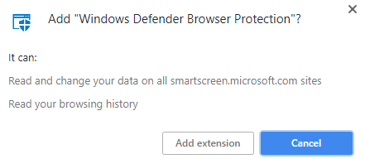

1. When complete, you will receive a notification of successful installation. To verify the extension has been added and is enabled, click on the extension in the upper right screen and verify settings.

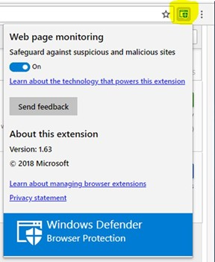

**Installing Windows Defender Browser Protection for Google Chrome Across an Organization Using a GPO**

Many organizations allow their users to select from a variety of Internet browsers they feel is safe for the environment and compatible with most sites (lowering help desk requests). As described above, SmartScreen is a feature that utilizes the large breadth of cyber intelligence Microsoft analyses and makes use of to provide safer environments for customers. The recent addition of SmartScreen capabilities as an extension in the Chrome browser is an extension of that capability. Below are instructions about how to locate and install the new extension to protect Chrome.

**Part I: Locate the Chrome Plug-In Extension Unique Identifier**

1. From within Chrome, let's go back to the Chrome Web Store by clicking on this link:

<https://chrome.google.com/webstore/category/extensions?hl=en>

1. In the Chrome Web Store search area, search for *Microsoft Defender Browser*.
2. When found, click on the name of the Extension to view the details. With the details of the extension displayed, the end of the URL has a Unique ID we need (highlighted below). For this version it is *bkbeeeffjjeopflfhgeknacdieedcoml*. Copy this area of the link (highlighted below) and paste it into a Notepad file to use later.

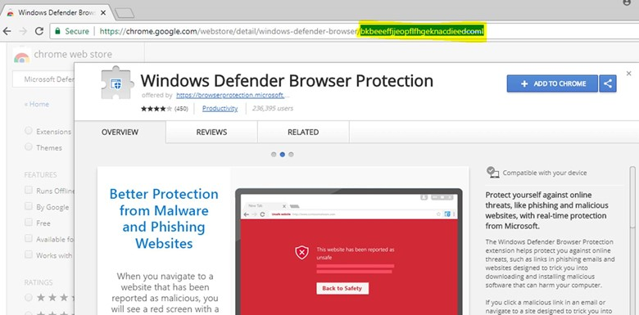

1. We now need to locate the URL used for the extension to download from. On the computer with Chrome now installed, open the directory below. Several of these folders are hidden, so make sure you have enabled the option to *View Hidden Folders i*n Windows Explorer. Note the Username will change according to the user you are logged in as. Also note that the version number below (1.63_0) may change over time (this was current as of July 2018).

C:\Users\kmartins\AppData\Local\Google\Chrome\User Data\Default\Extensions\bkbeeeffjjeopflfhgeknacdieedcoml\1.63_0

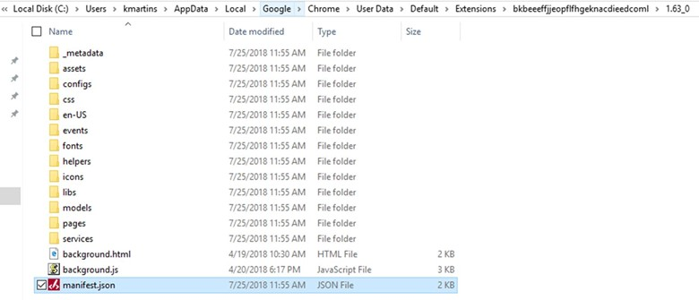

1. Within the directory above, locate the file named: *manifest.json*. Open it in Notepad or other text reader.
2. Copy the value entered for *update URL* which (for this extension) most likely will be <https://clients2.google.com/service/update2/crx> Again, be aware that this URL may change over time.
3. Paste the extension unique identifier copied earlier in step three into a new Notepad file. Add a semi-colon (;) to the end of it. Then, paste the URL you copied from the manfiest.json file in step six behind the semi-colon. There are no spaces needed anywhere in this line when complete.

My completed string is: *bkbeeeffjjeopflfhgeknacdieedcoml;https://clients2.google.com/service/update2/crx*

1. *With the string completed, we will now add this to the GPO for deployment to all users. I highly recommend you perform this action in a lab first, followed by a group of pilot users and computers.*

**Part II: Install Google Chrome Group Policy Templates**

1. Download the ZIP file of Google Chrome policy templates and documents from the site below:

<https://dl.google.com/dl/edgedl/chrome/policy/policy_templates.zip>

1. Within the ZIP file, locate the *chrome.ADMX* file.

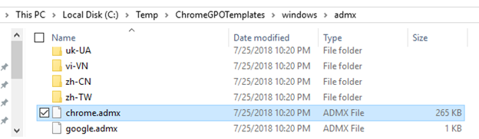

1. Copy the *chrome.admx* file to the central store in this directory:

*%logonserver%\sysvol\yourdomainname\Policies\PolicyDefinitions*

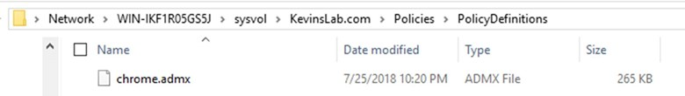

1. Back in the Chrome GPO Template ZIP file you downloaded earlier, locate the language folders you will need for your environment under the ADMX folder. Copy these folders into the *PolicyDefinitions* folder as well. In my example below, I am only copying the EN-US folder from the ZIP download and chrome.admx file to this location.

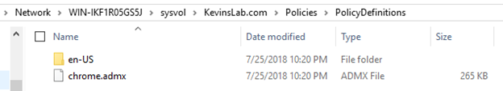

**Part III: Create the Group Policy to Install the Google Chrome Extension for Windows Defender Browser Protection**

1. On an Active Directory Domain Controller in your environment, open the Group Policy Management Console (GPMC). The fastest way to do this is to launch it from a Command Prompt by entering GPMC.msc.
2. Expand the Group Policy Objects area for your environment
3. Right click on *Group Policy Objects* and click *New*

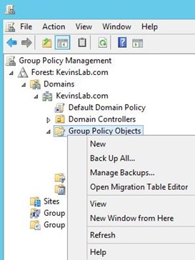

1. Name your *New GPO* (for example, *Google Chrome GPO Management*)

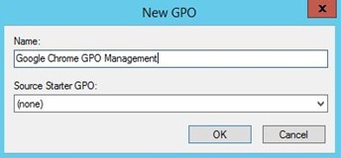

1. Right click on the new GPO you just created and select *Edit*

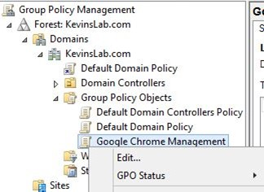

1. We want this extension to apply to all users where Google Chrome is installed. In the new GPO, expand Computer Configuration->Policies->Administrative Templates->Google Chrome->Extensions.

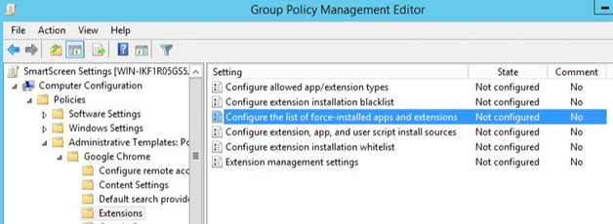

1. Choose the option "Configure the list of force-installed apps and extensions"

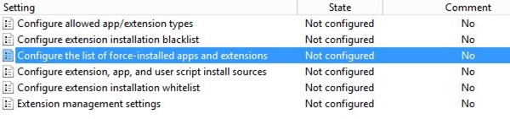

1. Change the option to be *Enabled*. Then click the *Show*.. option.

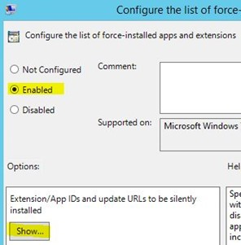

1. Using the script you created above in Part I, copy and paste it into the field. Click *OK* when done.

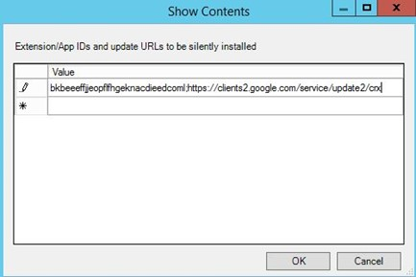

1. Verify the configuration option is now *Enabled*.

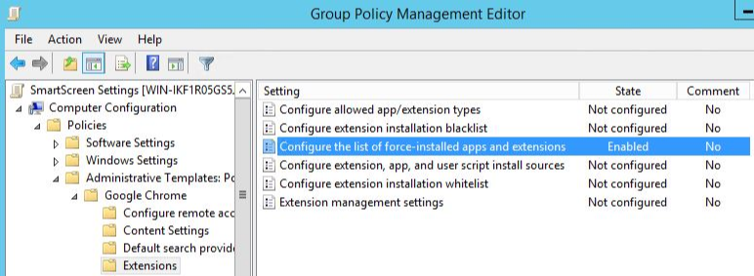

1. You can now close or minimize the Group Policy Management Editor but keep the Group Policy Console open to apply the policy.
2. In the Google Chrome Management Group Policy, I created an Active Directory Users Group called ChromeExtensionPilot and added a test user and target computer account to it. From there, I defined the group in the Security Filtering area. This is part of my pilot of the new GPO to deploy these settings on a limited scale first.
3. To verify this is working correctly, I logged into a domain joined test system as the pilot user. This pilot user was only in the User's group on the Windows 10 (1803) system, not an administrator. I first logged in as the pilot user to the test Windows 10 system, opened Google Chrome, and verified the extension was not listed.

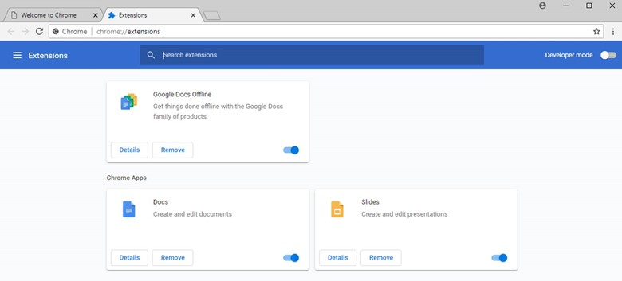

1. To force the new GPO to install, I opened a Command Prompt and ran the command *gpupdate /force*

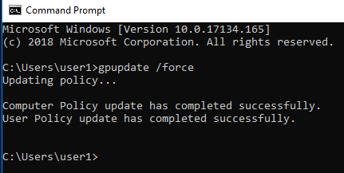

1. Within several minutes of issuing the command above, I was able to see the plug-in had installed (see icon in screen capture below). In my testing there was no restart of the Chrome browser needed.

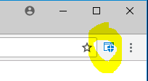

1. By clicking on the icon version and additional information is now displayed. The installation is now successful.

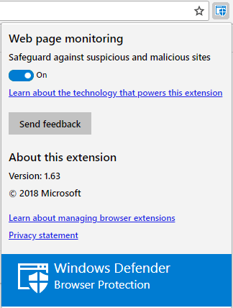

**Conclusion:** In this blog about Microsoft SmartScreen we reviewed how this feature helps to further secure an organization from users searching the web on Microsoft Internet Explorer, Microsoft Edge, and Google Chrome. Also provided were steps about how to configure options for policy management and deployment to all three browsers.

**Part 11: Monitor Phishing and SPAM Attacks in Office 365**

Within this blog series we have setup over ten locks that an attacker using phishing emails must overcome - reducing the likelihood of success. With many of these locks now in place, we need to monitor the effectiveness of our efforts to prevent these attacks from entering the network. We also want to monitor these policies to make sure they are not causing any negative impacts to communications in your organization. This must be done on a routine schedule by the systems administrator or security team.

Even though many adjustments in the environment have now been made to improve the security posture, this is not a finish line that signifies the complete security of your organization. Rather, this is an ongoing race to secure your organization against the ever evolving and growing sophistication of these cyber-attacks. As I discover additional features to implement and options to adjust, I will continue documenting them in future blogs.

Information about each threat report available in Office 365 has been documented in this [link](https://support.office.com/en-us/article/view-reports-for-office-365-advanced-threat-protection-e47e838c-d99e-4c0b-b9aa-e66c4fae902f?ui=en-US&rs=en-US&ad=US) that I highly recommend you review. Below are instructions to access the reports and how to schedule key reports to be sent for review periodically.

**Accessing the Advanced Threat Protection Reports**

1. Logon to <https://protection.office.com> as a global administrator account.
2. On the left side of the screen, click *Reports* to expand the list of reports.
3. Click *Dashboard*
4. Here, we can see several ATP reports, malware detection reports, SPAM detection reports, etc. to choose from.
5. The reports I find most useful and insightful in the attacks on an environment are:
   * Threat Protection Status
   * Malware Detections
   * ATP File Types
   * SPAM Detections
   * Spoof Mail

**Schedule Email Delivery of Key Security Reports**

To keep track of the types of attacks your organization is experiencing, I recommend you either logon to the reporting portal on a periodic basis and/or schedule reports to be emailed to you and your support team for review.

When you click on each of the reports, you are presented with the option to *Create a Schedule* for email delivery. Below are some quick steps for creating these reports.

1. As an example report to schedule, click on the *Advanced Threat Protection File Types Report*.
2. Click the option to *+Create Schedule*



1. You are now presented with a standard report schedule that may be accepted as is or may be customized. To customize the schedule, under *Options*, select *Customize Schedule*.

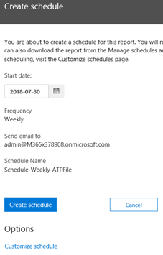

1. Using the options presented, you can adjust the scheduled report name, frequency of delivery, email recipients (to you and/or a security monitoring team), etc. I suggest you choose only a few key reports for delivery. Scheduling any more than a few reports will just become noise in your Inbox, and you will not make the time to review them.
2. To review and modify all scheduled reports, click the option to *Manage Schedules* under the *Reports* section of the *Security & Compliance* area. Below, you can see one of the sample report I have scheduled for delivery.

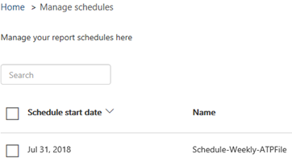

**Conclusion:** In this blog, we reviewed information about the Microsoft Security Reports available for review. We also reviewed why these are important to frequently review to gain valuable insights into the attacks your organization is experiencing. It is through this understanding that you will understand how to adjust settings to help mitigate against the latest attack vectors without causing an impact to user productivity.

**Part 12: Discover Exactly Who is Attacking Your Office 365 User Identities**Within this blog series we have setup over ten locks that an attacker using phishing emails must overcome - reducing the likelihood of a successful attack. While Part 11 of this series highlights many of the reports available to review detected SPAM, Phishing and other types of detected malicious activity, another great nugget of security information is the availability to see just how often attackers are trying to logon as your users. And, if they were successful or not. Whether you are a small five-person organization, medium 500, or large 50,000 user enterprise, the information available in this blog is both eye opening and sometimes alarming for technical and security teams.

Using reporting available in the Azure Active Directory Premium P1 subscription or a 30-day trial for P2, you will quickly gain valuable insight into threats against your organization. This blog will explain how to:

* See which of your user accounts are the most heavily attacked in terms of who is trying to guess their usernames and passwords. Some user accounts, such as those for a leadership team, are often more attacked than others.
* Identify if a user account has been breached and take quick action.
* Download detailed information in a Microsoft Excel or CSV file format for data sorting.
* Sort information about where these attacks are coming from based on country location.

Let's move forward with how to get access to this data and review the results…

**Setup License to Access User Identity Attack Information (Including a 30-Day Trial)**

Azure Active Directory is available in four editions (Free, Basic, Premium P1 and Premium P2). To see a comparison of each edition, review a table available in this [link](https://azure.microsoft.com/en-us/pricing/details/active-directory/). Detailed information about each edition is available within the document [What is Azure Active Directory?](https://docs.microsoft.com/en-us/azure/active-directory/fundamentals/active-directory-whatis)

The information we want to review in this blog is available with a license for Azure Active Directory Premium P1 or P2. If you do not have this as part of your subscription, I have included step by step information below about how-to setup the free trial license to see this information.

Let's first see what type of Azure Active Directory License your organization has using the steps below.

1. Logon to *portal.azure.com* as a *global administrator*
2. In the index of features on the left, select *Azure Active Directory*
3. By default, *Overview* will be highlighted
4. Which license do you have?
   1. In the *Overview* section, if you see the screen below with the text "To see sign-in data, your organization needs Azure AD Premium P1 or P2. Start free trial." then proceed to the next section to enable the 30-day trial license.

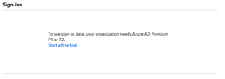

* 1. In the *Overview* section, if you see the screen below with sign-in event information for your organization then you have the license needed to view the data.

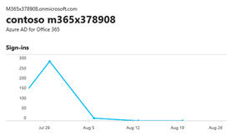

**Setup Free Trial of Azure Active Directory Premium P2**

If your organization does not currently have Azure Active Directory Premium P1 or P2 to view logon information, use the steps below to setup a free 30-day trial. Otherwise, continue on to the next section to view the information.

Although Azure Active Directory P1 is needed to view the information, the trial is for P2 which is why we are setting up the subscription for P2.

1. In the screen above (step 4a), click on the link to *Start a free Tria*l.
2. You now see two trial options available. One for *Enterprise Mobility and Security E5* (a future blog) and second option for *Azure AD Premium P2*. Click on the *Free Trial* in *Azure AD Premium P2*.

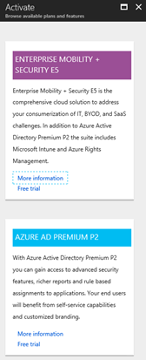

1. In the next screen, information about the trial is displayed. After reviewing the information, click *Activate*.

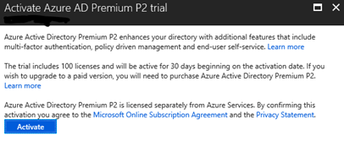

1. Within several seconds, a notification of a successful activation for this trial is displayed in the upper right corner.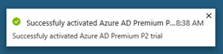
2. With the trial subscription now activated, in the same Azure Portal screen click on the *Azure Active Directory* option in the index on the left side of the screen. You will now see sign-in information for your Azure AD users in Office 365.

**View Office 365 Sign-In (and Attempted Sign-In) Information**

1. When logged in to the Azure Portal at *portal.azure.com*, click on *Azure Active Directory* in the left index area.
2. Now displayed is a summary graph of Office 365 User Sign-In information. *Click* directly on the summary graph to view detailed information.

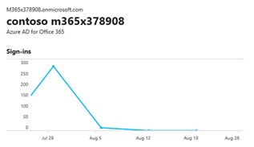

1. We now start to see some interesting details such as the user sign-in, what application was used to sign-in, was a conditional access policy applied (future blog) and was Multi-Factor Authentication (MFA) required? In my demo tenant data below, notice my global administrator account required MFA but a user named Megan Bowen did not.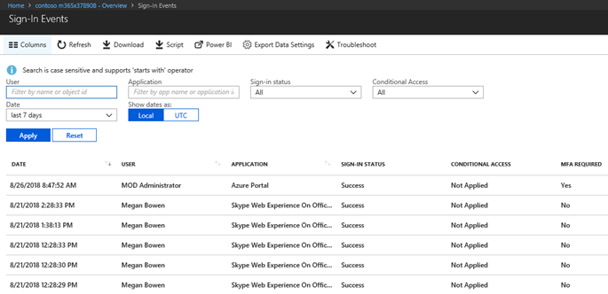
2. Depending on your organization size, there may be a great deal of logon activity to scroll through. From this screen, you can review *Successful* and *Failed* logon events by choosing the options in *Sign-In Status*.  
   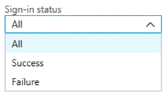
3. In this view, we are still not seeing all the information available. Let's make this a bit more interesting and gather detailed information to review the points highlighted in the beginning of this blog.

**Download Detailed Sign-In Events**

1. Within the same Azure Portal view as above, click on the Download link

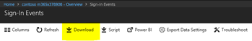

1. The detailed information downloads in a CSV format by default.
2. Open the file in Microsoft Excel. I usually start by sorting entries at the top of each column. Do this by highlighting a cell in row one where the column data heading is. Then select *Sort &Filter* on the Excel ribbon in the upper right. Then select *Filter* in the drop-down options.

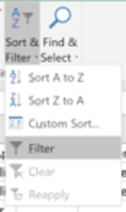

1. With a drop-down filter now added for each column heading, we can start to review data logged for suspicious logon activity. Below, I set the stage a bit more for the data shown from this fictitious company.

***Scenario:*** As we begin to review the sign-in information, consider the scenario of your own tenant. Are you a small business who operates in one specific region, a State, a Province, etc. Perhaps you are a mid-size company or even an enterprise company where you have traveling sales people. For your organization, you will most likely know your users and where they typically operate from. Even more importantly, you will know where your organization does not operate and therefore be able to identify suspicious logon activities from regions of the world where your users would never travel to.

The data presented in this blog is fictitious from a demonstration tenant in Office 365, but represents user logon names, applications, locations, etc. data you may see in your logs.

The data presented here has been modified a bit for our scenario to represent a small-mid size company operating in the Maryland area of the United States.

***Note:*** The IP addresses in this list have been obscured but know that you will get exact source IP addresses listed in your data. I also removed a few columns not needed for this type of data review.

1. At a first glance at this data, I see what looks like normal logon information. The sign-in information from cities in Maryland are normal, the usernames look right, there are successful logon events, etc. We even see that some users have Multi Factor Authentication (MFA) enabled while others do not.

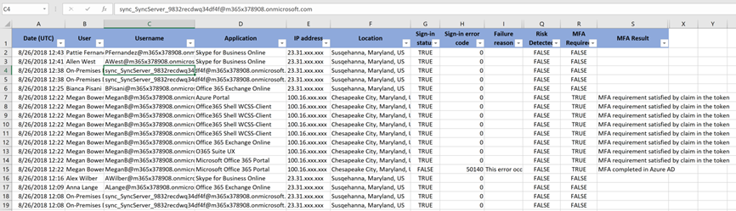

1. While the information displayed so far appears normal, let's see where other logons are coming from. In my column F, I'll select the filter drop down option to display the location values in this long list. Now this starts to get interesting.

Remember my demo tenant scenario of being a small-mid size organization in the Maryland state area. I know my users do not travel as part of their work outside of the region and while it is possible an employee or two may be traveling the world on vacation, it is not likely.

So looking at the now sorted data, I now see attempted logon attempts from a long list of cities and countries where I shouldn't be seeing any activity from.

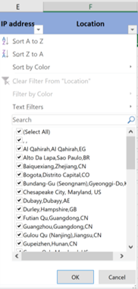

1. I want to research more information about these logons and will therefore go through the list of locations and deselect all of the Maryland and surrounding areas found in the list above, leaving me with mostly international locations. Now this really starts to get interesting in the list below. The frequency and widespread logon attempts from attackers attempting to access your network is now in full view.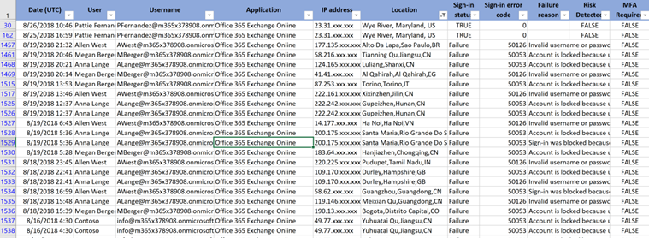
2. In addition to understanding where logon attempts are coming from to access your organization's resources, there is additional information to review:

a.   I also want to see the *Failures* listed in the Sign-in Status column. In the screen capture below where we are sorted on locations other than where our organization operates, also sort on the *Sign-In Status* column to see where *Success* is located. From here, be sure to look for any *Success* status listed for suspicious locations. If seen, you need to assume you have a breach in your organization and take appropriate action to protect your organization - starting with the user account that appears to be breached in this report.

b.   A scan of the data will also reveal who your most attacked users are. Is it someone from your leadership team with financial approval, is it a webmaster or admin email account that has been published on the Internet, or even an info@domain.com address listed on your website? This data should be used to generate a report to the leadership team of your organization with a recommendation of actions to take (such as enable MFA for all users).

**This is Great Information, But What Can You Do Now?**

As I stated early in this blog, this information is both interesting and may be alarming to find out just who and how often your organization is experiencing suspicious logon attempts. This information is a great way to see where logons are being attempted from as well as to see if they are successful.

Remember, an attacker has all the time in the world to guess a username and password. It only takes one successful match for a breach to take place. You can do several tasks outlined in this blog series to make it more difficult for an attacker to attempt logons to your organization such as blocking logons from locations other than where your users normally operate. Also, you can enable MFA on all user accounts so that even if an attacker is successful with a username and password combination, they will not be able to gain access to the environment.

[Part 3: Deploy Multi Factor Authentication (MFA)](https://blogs.technet.microsoft.com/cloudready/2018/07/31/email-phishing-protection-guide-part-3-enable-multi-factor-authentication-mfa/)

[Part 5: Define Country and Region Logon Restrictions for Office 365 and Azure Services](https://blogs.technet.microsoft.com/cloudready/2018/07/31/email-phishing-protection-guide-part-5-define-geographic-logon-restrictions-for-office-365-and-azure-services/)

This data is being presented as part of a 30-day trial license to Azure Active Directory Premium P2 for some readers. If on the trial, consider subscribing to this license to periodically review this data and further protect all of your users. The data collected in this report using the P2 license is just one of many features available with this subscription as described in this [site](https://docs.microsoft.com/en-us/azure/active-directory/fundamentals/active-directory-whatis).

**Summary**

This blog series highlights many items available in Office 365 and Microsoft Azure that can be implemented to help increase the security posture of most organizations. This blog explains how to use logon information from Microsoft Azure Active Directory to view where attempts to logon to your environment are coming from.

Remember, the best posture you can take to protect the security of your organization is to assume breach. Using data such as this will enable you to help find where attackers have breached your organization and how to take action to prevent it in the future.

**Part 13: Update Your User Identity Password Strategy**

Earlier in this blog series, I highlighted how often the Office 365 identities in your tenant may be attacked by providing steps to view the information. While I also outlined in [Part Three](https://blogs.technet.microsoft.com/cloudready/2018/07/31/email-phishing-protection-guide-part-3-enable-multi-factor-authentication-mfa/) of this series how important and strongly recommended it is to enable Multi Factor Authentication (MFA) for all your users, what if you do not yet have this feature in place? What if your organization has not yet embraced MFA and instead has chosen to continue with a username and password approach? How can this strategy be enhanced to increase security?

For decades, the strategy about password policies has included items such as:

* Change a password every 30 days
* Require complexity in passwords
* Force passwords to be 9,10, or more characters in length

What if I were to tell you that these are no longer recommended based on research done in recent years? Yes, this was a bit of a shock to me when I first started looking into this as well. After all, this is how password policies have been set in my 25+ years of experience in system design and administration. With new threats evolving each day, it is imperative to the security of your organization that you understand why the policies mentioned above (while still better than nothing) are no longer recommended, as well as what is now recommended and why.

Before we get into recent research about passwords, let's look at how people have been using passwords for years. Consider some of your first uses of computer passwords. Perhaps it was for your first CompuServe account, Prodigy account, or perhaps a Blockbuster account. You had a username and password in that former age of dial-up modem Internet connections. Chances are you used something simple to remember. For example, suppose your favourite animal was a lion - so you had a password of *lion* on these first types of accounts. As time went on, you signed up for more accounts on your favourite travel website, for your local grocery store, your favourite hotel chain, and many more we can all identify with. Chances are, that same password or some variant of it is still being used on modern websites and for your work account. Perhaps it evolved to *Lion* with a capital *L*, or *Lion5* because you are incrementing numbers, or *Lion09187*9 because that is your birthday, or perhaps *Lion091879!#* because your employer or your bank website now requires special characters in a password.

Now consider your username at work. It is probably some variant of your first name and last name. Don Smith's username could be Dsmith@domain.com or DonS@domain.com or Don.Smith@domain.com. Something that is common and easily guessed.

As a security professional reading this, you may know better than using a password strategy like the one outlined above. But keep in mind, your users are not nearly as concerned with network security. They are likely doing the minimum required to satisfy password requirements you have had in place for years. And, they are using the same or similar password on your network for every other personal account they have so 50 different passwords do not need to be remembered. We are all human and will try to keep things simple.

Now consider an email phishing attack and then the logon attacks you now see after following the steps in [Part 12](https://blogs.technet.microsoft.com/cloudready/2018/08/27/email-phishing-protection-guide-part-12-discover-exactly-who-is-attacking-your-office-365-user-identities/) of this blog series.

Let's say an email phishing attack was successful and a user entered his/her username and password. The attacker was able to logon to this identity because you did not have MFA enabled (hint: enable MFA). Although you were able to quickly identify the breach and force a password change on the account before any *apparent* damage was done, the attacker was able to get a few key pieces of information for a new targeted attack:

* The user who fell victim to the phishing email entered a username using the format used throughout your environment. The attacker now knows this format, providing a key piece of information.
* The attacker was able to harvest your user directory. He or she now knows the username and email address of everyone in your organization. Perhaps he or she knows the job titles of each person as well if that field is populated in your directory, including individuals who are managers or part of the executive leadership team. Algorithms can now be adjusted for a spear phishing attack against these high value identities with a much higher likelihood of success.

Although the attack and breach were quickly identified and remediated, the attacker can now launch a more targeted attack. Certainly the attacker will continue with an email phishing campaign, but with detailed information now known about your organization the attacker can be much more targeted. Consider the attack scenarios that can now be used:

* With a directory of your users now in the hands of an attacker, names can be researched on social media sites to find out more about each person. Algorithms can then be adjusted to include passwords that may include (using our example above) your favourite animal with a combination of special characters and capitalization. If you can think of the potential password combinations, the algorithms are designed to try them as well. This type of attack can go on for weeks, months, years, but the probability of a successful password guess grows higher each day.
* With additional information learned from social media sites about your users, an attacker could determine where each user has other accounts. Although your organization may have fortified its network defences in various ways, consider this: 'have these social media sites done the same?' An attacker could start logon attempts at these social media sites using the user email addresses discovered in the original attack and again start to guess passwords there with information now known. A successful password guess on one of those sites is now just another clue to a successful password into your organization. If an attacker successfully guessed you are using *Lion42* as your password in a social media site, algorithms can then be further fine-tuned to try variants on the identities used at the primary attacker's target.

The list of these scenarios goes on and on. Remember that these attackers are smart, very smart. This is about money to them and this is a business many are running with a lot of great resources and intelligent software developers. A nation-state sponsored attack has even more, almost unlimited, resources. They all have all the time in the world to successfully guess user identity usernames and passwords. With each additional data point(s) known about an organization, the easier it becomes for a successful breach to happen.

**A New Password Strategy:**

With all of this in mind, what can you do? First, keep in mind that these types of attacks are not just for cloud identities, but for any identity hosted anywhere - on-premises or in any cloud vendor environment. Also consider that cloud environments gather attack intelligence from millions of ongoing attacks and use them to help fortify and adjust the security of the environments. For Microsoft, we see more than 10 million attacks involving passwords each day ([reference](https://info.microsoft.com/MicrosoftPasswordGuidance.html)). This is far more telemetry than any on-premises system can provide, and far more than most other vendors can gather. The information is analysed, and mitigations quickly enabled, making a cloud environment the safest infrastructure available for your organization and data. See more information about the Microsoft Intelligent Security Graph [here](https://www.microsoft.com/en-us/security/intelligence).

Microsoft Research has published a detailed whitepaper describing the volume and types of attacks Microsoft sees and learns from each day. These attacks never stop and are only growing. I recommend you take a few minutes to review the research and recommendations in [this whitepaper](https://www.microsoft.com/en-us/research/wp-content/uploads/2016/06/Microsoft_Password_Guidance-1.pdf). Then, I recommend you implement many, if not all of these recommendations in your organization. Remember that you cannot simply enable these recommendations. You will need leadership support, a communication plan to your users about why you are making this change and what they can expect, and then plan how you will test and pilot these new policies.

The first part of this effort is often the most challenging - gaining leadership support. In your presentation to leadership, use the telemetry in the Microsoft Research whitepaper AND collect your own data from [Part 12](https://blogs.technet.microsoft.com/cloudready/2018/08/27/email-phishing-protection-guide-part-12-discover-exactly-who-is-attacking-your-office-365-user-identities/) in this blog series. Make your presentation real with data about attacks your organization has against it every day and remind your audience that a breach is just a user click away from a well-crafted phishing email.

From the [Microsoft Research whitepaper](https://www.microsoft.com/en-us/research/wp-content/uploads/2016/06/Microsoft_Password_Guidance-1.pdf) on password guidance, below is advice offered for policies to enable in your organization using both Azure Active Directory and Active Directory:

1. Maintain an 8-character minimum length requirement (and longer is not necessarily better)

2. Eliminate character-composition requirements

3. Eliminate mandatory periodic password resets for user accounts

4. Ban common passwords, to keep the most vulnerable passwords out of your system

5. Educate your users not to re-use their password for non-work-related purposes

6. Enforce registration for multi-factor authentication

7. Enable risk based multi-factor authentication challenges

Be sure to review the recommendations above, the data provided in the Microsoft Research Paper, data on attacks against your Office 365 identities each day, steps provided in the [Email Phishing Protection Guide](https://blogs.technet.microsoft.com/cloudready/2018/07/31/introduction-email-phishing-protection-guide-enhancing-your-organizations-security-posture/), and then develop a new strategy for your organization designed to protect your user identities. Keep in mind that email phishing is one of the newest, most popular and growing types of attacks against your organization today. You must get ahead of this threat, maintain your awareness of new attack vectors, and evolve your security posture accordingly.

**An Even Better Strategy - Eliminate Passwords from your Organization**

As you evaluate your current password policies and consider a modern strategy, also consider that the best way to protect user identities is to work towards eliminating passwords altogether. This sounds like another strange concept to introduce, but it is something Microsoft has been working on to help provide even more security for user identities. Below are a few blogs with more information about this strategy.

[Building a World Without Passwords](https://cloudblogs.microsoft.com/microsoftsecure/2018/05/01/building-a-world-without-passwords/)

[Implementing Windows Hello](https://blogs.technet.microsoft.com/cloudready/2018/07/31/email-phishing-protection-guide-part-4-deploy-windows-hello/)

**Part 14: Discover Weak Passwords to Prevent Brute Force and Spray Attacks**

In a previous [blog](https://blogs.technet.microsoft.com/cloudready/2018/09/09/email-phishing-protection-guide-part-13-update-your-user-identity-password-strategy/) I wrote about how it is time to change your user password strategies that have been in place for decades to something new and more complex. I provided several recommendations from a recent Microsoft Research paper about our recommendations based on years of research. In addition to these recommendations, there are additional actions you can take to discover weak passwords being used in your environment as well as how to prevent the use of common passwords used and that attackers are using in dictionary attacks. How about running an attack on your own environment to see just how vulnerable user passwords are?

See the different sections below to learn more about these valuable techniques to further secure your environment:

* Perform a Brute Force Password Attack
* Perform a Password Spray Attack

**Perform a Brute Force Password Attack**

A Brute Force password attack is typically launched against a targeted set of high-profile users. These are users that could be part of a company's leadership team or someone with financial approving authorization. A dictionary of commonly used passwords is used to continuously try to guess the password of these specific users. Beyond the common passwords, also used are passwords based on a local sports team, the current weather season, the holiday season, project names used specifically within a company, etc.

While many have experienced this breach scenario, others can only imagine what could happen… Imagine the username and password of your Chief Financial Officer (CFO) was discovered by an attacker. That attacker could use the CFO's account to request a wire transfer to an account by someone in the financial department. The money would be wired to the (attackers) account and no one would think a thing of it. The email/request came from the CFO as it may have been done many times before. There is typically no insurance on wire transfers and since the receiving account is outside of your country, there is usually no way to recover the funds. This scenario is playing out time and time again resulting in wire fraud that can be detrimental to a business. This is a recent FBI [article](https://www.fbi.gov/contact-us/field-offices/phoenix/news/press-releases/fbi-warns-of-dramatic-increase-in-business-e-mail-scams) about the practice that has damages into the billions of dollars.

As I've stated in earlier blogs, remember that the attackers are extremely smart people who write complex algorithms used in these attacks. They have all the time in the world to attack you, yet only need to be successful in the username and password combination once. You must make sure none of these easy to guess passwords are being used in your environment. Using the Brute Force and Password Spray Password attack utilities in Microsoft Office 365, this is now possible and easy to run.

Before you proceed, note that neither of these attack utilities will display user passwords in the results. Rather, it will only identify individuals using weak or commonly used passwords. Users will be unaware this type of attack is running, so there will be no impact.

Note: You must enable Multi-Factor Authentication (MFA) on the account you will logon as to setup and execute the attack. MFA is not required on the accounts you will be attacking.

1. As a global administrator with MFA enabled, logon to <https://protection.office.com>
2. Expand *Threat Management* and then click on *Attack Simulator*.
3. Locate the middle option called *Brute Force Password (Dictionary Attack).*

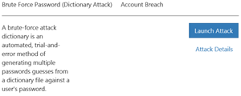

1. Click on the *Launch Attack* option.
2. Provide a name for the new attack and click *Next*.

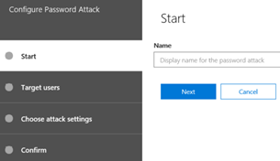

1. Select several users to target or select a group of users. Names of users and groups will auto populate as you start to type them.

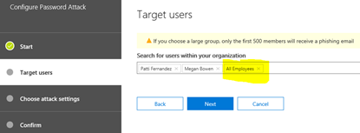

1. In the next screen, enter each password you would like to use in the attack. As you enter each password, press *Enter*. After each value entered, you will see a series of dots appear instead of the password just entered. You may also search for a dictionary of common passwords on the Internet to use that can then be uploaded for use. Be cautious in your search for these dictionary attacks as several I located did not appear safe for download and use.

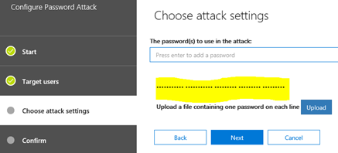

1. Confirm that you are ready to start the attack and click *Finish* to begin.

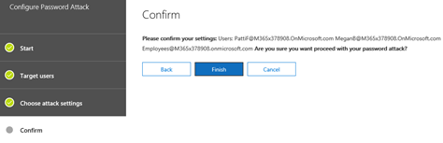

1. After a few minutes, depending on how many users you are running the brute force password attack against and/or the number of passwords used, the attack details should be ready to view. On a refresh of the screen, you will find a note indicating the attack has been completed.

Click on the option to *View Repor*t to see the results

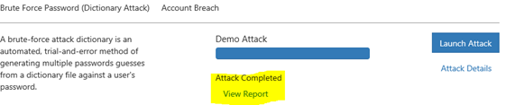

1. We can see in the report below that two of the users I selected in this attack were found to be using weak passwords or passwords in the specific list I entered. In all fairness, for this example I entered the passwords used for a few of these users in this demonstration tenant environment (these are fictitious accounts).

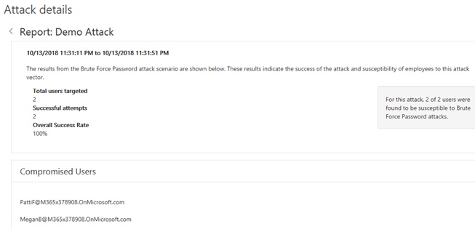

**Summary:** You have now identified the users in your organization using weak passwords. If these users are part of your company leadership team or anyone with financial approving capabilities, I recommend you work with them to develop a more complex password and enable MFA as soon as possible.

**Perform a Password Spray Attack**

A Password Spray Attack is similar to a Brute Force Attack, but instead of using a dictionary of possibly millions of password combinations at specific users, in this attack a single password is tried against a list of many valid Office 365 users.

Many password policies will detect multiple bad password logon attempts within a period of several minutes and lock an account for a specified period of time. Again, attackers are smart and know this policy well. To avoid detection, they will move down a long list of users for each password try so no single account has a multiple sign in attempts in a short period of time. Remember, an attacker has all the time in the world to guess the right combination of a username and password. Eventually, they will win if you allow easy to guess and commonly used passwords by your users.

With this in mind, let's setup a Password Spray Attack in the environment.

Note: You must enable Multi-Factor Authentication (MFA) on the account you will logon as to setup and execute the attack. MFA is not required on the accounts you will be attacking.

1. As a global administrator with MFA enabled, logon to <https://protection.office.com>
2. Expand *Threat Management* and then click on *Attack Simulator*.
3. Locate the middle option called *Password Spray Attack*.

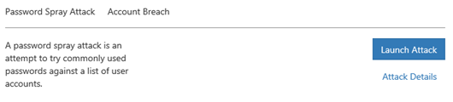

1. Click on the *Launch Attack* option.
2. Provide a name for the new password spray attack.

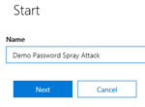

1. Enter the user names or groups of users you want to run this attack against.

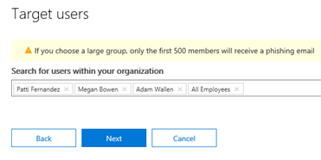

1. Enter the password you want to use in this attack. You can only enter a single password in this attack that will then be used to logon to all the users you identified.

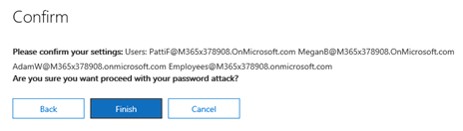

1. Click *Finish* to begin the attack.
2. Click on the *Refresh* button at the top of this screen. Notice that the attack has been completed and you are given an option to *View Report*.

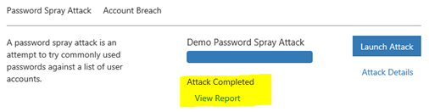

1. Click on the *View Report* option. Note that two of the users were breached by using the password examples I provided in this example.

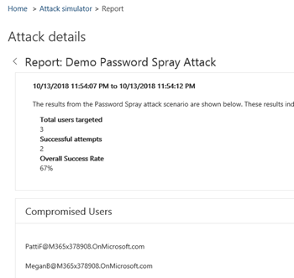

**Summary:**

You now have a known list of users using a password that may be as common as just "Password!" You can now work with them with a request to change their password. It is also highly recommended to enable MFA on administrator and user accounts.

**Part 15: Implement the Microsoft Azure AD Password Protection Service (for On-Premises too!)**

Microsoft has a very large user base across 200+ products such as Office 365, Outlook.com, Hotmail.com, Xbox Live, etc. and with that, receives billions of authentication requests - many legitimate from real users, while many were from attackers.

In August 2018, Microsoft blocked over 1.29 billion (yes, billion) authentication requests from malicious attempts to obtain a username and password. Many of these come from password spray attacks which is when an attacker has a set of commonly used passwords that are then used in an attempt to guess the password of a defined set of user accounts. The thinking is that one of these passwords will be common enough to match what a user has chosen for their password. Remember, attackers are smart and know the typical passwords people use such as incrementing a common password by a number each time they are required to change it, use an exclamation point or some other character at the end, etc. They have advanced algorithms to help work through these password combinations as well as password dictionaries available from the Internet that contains millions of passwords. While commonly targeted accounts are often from those in leadership positions at an organization, other user accounts are valuable as well. If an attacker can get access a sales person's account, a logistical planning person, a user who stocks shelves at a store, etc. he or she can then begin to look around the rest of the organization for valuable data, harvest the email directory to perform additional targeted attacks, and more. The attacker has all the time in the world to look around once they are in and start to work their way through the organization.

To increase an organization's security posture, there are many locks and adjustments that should be made as described in this blog series. When it comes to passwords, adopting a password-less strategy using Windows Hello, the Microsoft Authenticator app, and/or FIDO2 security keys is highly recommended. If you are unable to start the password-less journey in your organization and need to fortify your user accounts quickly, the modernization of password policies is needed as described in the previous [blog](https://blogs.technet.microsoft.com/cloudready/2018/09/09/email-phishing-protection-guide-part-13-update-your-user-identity-password-strategy/). In addition to these strategies, consider using the features Microsoft now has in place both in the cloud and on-premises to prevent the use of these easy to guess passwords.

With the recently launched (June 2018) Azure Active Directory Password Protection service you can prevent cloud and on-premises Active Directory users from using commonly used passwords. This is a great way to defend against the commonly used password spray attacks. By using this service, some organizations were able to determine that up to 52% of the passwords used in their organization were weak and easily guessed by attackers, and then able to significantly reduce the attack surface. The list of these commonly used passwords is determined by analysing the attack patterns from across the Microsoft cloud and developing a list of the weak strings being used to attack with. This list is a dynamic global list that is constantly updated based on new attacks and is one of the items used by the Azure Active Directory Password Protection service.

While this works well for Azure Active Directory cloud users, there is also a way to extend this same service to on-premises Active Directory Domain Controllers. This is done by installing a small agent either directly on the domain controllers or, if you block direct Internet access to domain controllers you can instead install a proxy agent on another server for them to use. If using the proxy agent setup or direct domain controller communication, password changes will use end-to-end encryption between the domain controller and Azure.

The agents are lightweight, quick to setup and highly recommended to take advantage of Azure Active Directory Password Protection. Once setup, you will want to first use only the *Audit* mode to see how many users are using weak passwords. After additional planning, the Audit mode can be switched to *Enforced*. The service supports multi-forest environments as well as a high availability architecture. As of September 2018, this service remains in a public preview.

Below are instructions about how to view current settings in Azure Active Directory Information Protection and how to set this up on-premises. For additional information, diagrams, agent downloads, and answers to common questions about this service, see the [reference documentation](https://docs.microsoft.com/en-us/azure/active-directory/authentication/concept-password-ban-bad-on-premises).

**Microsoft Azure Active Directory:**

1. Logon to <https://portal.azure.com> as a global administrator.
2. Click on *Azure Active Directory*

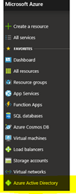

1. Click on *Authentication Methods*

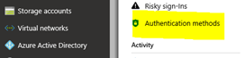

1. In this screen, you can configure the custom smart lockout functions for Azure AD users. Keep in mind that these lockout threshold and durations are only for Azure AD users. Active Directory still has its own lockout and password protection policies that is in place for on-premises based users. Azure Active Directory Password Protection is in addition to this.

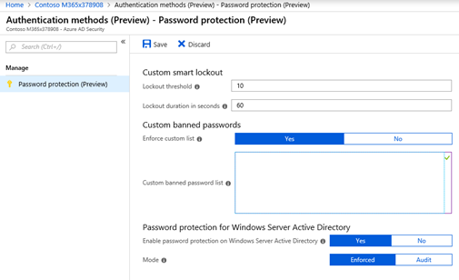

1. In the screen above, in addition to the list of passwords Microsoft is preventing by default (this default list is never exposed as to not give attackers any insight), you may enter custom passwords to block from being used. In this custom list, you may want to enter terms such as the sports teams local to your office locations, your organization's name, key project names, key products a company produces, and anything else that users in your organization may typically use. You can then test this policy by using a test user account in Azure AD.
2. Also in the screen above, notice the two settings for Windows Server Active Directory. These are for your on-premises Active Directory Domain Controllers (covered in next section). When ready, set the first option to enable password protection to *Yes* and then set the *Mode* to *Audit*.

**Microsoft Active Directory (On-Premises) Password Protection Agent Installation**

Before you get started to implement the on-premises portion of this setup, be sure to read the requirements section of the service documentation. It is important to note that each domain controller must have an agent installed to participate in this protection service.

Below are instructions for how to install the Active Directory Password Protection Proxy agent as well as the Domain Controller agent. I recommend installing this agent FIRST in a testing, non-production environment. For additional information on this process, see the installation guide [here](https://docs.microsoft.com/en-us/azure/active-directory/authentication/howto-password-ban-bad-on-premises).

1. Go do the [download site](https://www.microsoft.com/en-us/download/details.aspx?id=57071) to access the Domain Controller agent as well as the Protection Proxy agent. Select both for download.

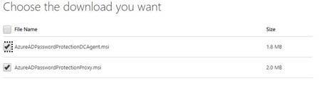

1. On your first domain controller, open the *AzureADPasswordProtectionProxy.msi* file to start the installation. Click *Install* to initiate the installation. This will take under 30 seconds to complete.

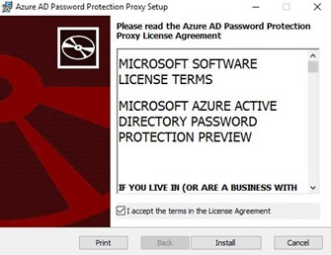

1. The Installation completes within about ten seconds. Click *Finish* to end the installer and proceed to the next step. There is no reboot required for the proxy agent installation.

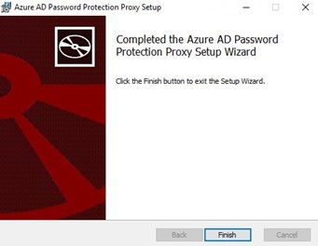

1. You must now register the proxy and the Active Directory Forest to communicate with Azure. These steps are done in PowerShell.
   1. Open PowerShell in Administrator mode
   2. Make sure the Azure AD password Protection Proxy agent is running by typing: *get-service AzureADPasswordProtectionProxy*.

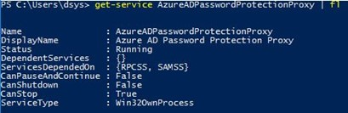

* 1. Register the proxy agent with Azure Active Directory by typing: *Register-AzureADPasswordProtectionProx*y. You will be prompted for credentials.

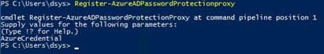

* 1. Register the on-premises Active Directory Forest with Azure Active Directory by entering: Register-AzureADPasswordProtectionForest. You will again be prompted for credentials.

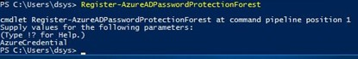

* 1. If needed, you may change the port the Azure AD Password Protection Proxy Service is listening on. Use instructions [here](https://docs.microsoft.com/en-us/azure/active-directory/authentication/howto-password-ban-bad-on-premises) if needed.

1. On the first domain controller, open the downloaded Domain Controller agent and select *Install* to start the installation.

**Note**: A reboot will be required to complete the installation of the domain controller agent.

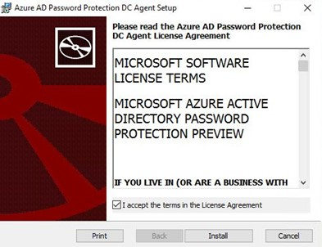

1. Within a few seconds, the installation is complete.

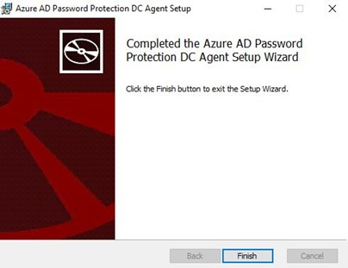

1. The agent installer will prompt for a reboot of the domain controller.

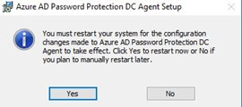

1. After the domain controller agent is installed and the domain controller has rebooted, there is no other configuration required on the servers.
2. At this point, make sure to follow the options in the *Password Protection for Windows Server Active Directory* below are set correctly. Select *Yes* to enable the Windows Server Active Directory protection and set the Mode to *Audit*.

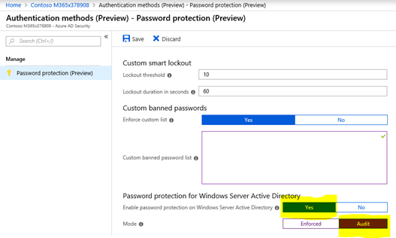

1. Information about monitoring the domain controller agent and proxy agent is located [here](https://docs.microsoft.com/en-us/azure/active-directory/authentication/howto-password-ban-bad-on-premises-troubleshoot). Once ready, go back to the configuration in the previous step and change the *Mode* to *Enforced*.

**Summary:**

By eliminating the use of easy to guess and commonly used weak passwords in your environment, you are further shrinking the attack landscape. To provide even more secure logon capabilities, it is recommended that you update aging password policies, use Windows Hello, FIDO2 keys and the Microsoft Authenticator app.

**Part 16: Disable Office 365 Legacy Email Authentication Protocols**

In an earlier blog, I wrote about password spray and brute force password attacks. As talked about at Microsoft Ignite 2018, almost all of the password spray attacks Microsoft identifies are using legacy authentication protocols. This blog provides background on legacy and modern authentication applications as well as how to define conditional access policies to block this popular attack vector. A new conditional access policy to block this attack was released in June 2018 and has been implemented by thousands of cloud tenants already.

Before you get started, a note of caution. Before designing and applying a Conditional Access policy, be sure you fully understand the design and impact. I always recommend doing this in a test environment first and/or using the What If feature in the Conditional Policy design area.

Newer Office based applications are enabled for Modern Authentication using Active Directory Authentication Library (ADAL) sign-ins. These and other Modern Authentication enabled clients utilize more secure sign-in options such as Multi-Factor Authentication (MFA), smart card, or certificate-based authentication. Modern Authentication has been available for several years in applications many organizations have already transitioned to. However, the capability to use Legacy Authentication methods remain available and should be disabled to further secure an environment.

With this authentication method still enabled, an attacker can use a username and password combination to attempt to gain access to your environment. With this access, the attacker can send and receive email as the user whose account has been breached and launch a reconnaissance process in your network. Before taking any action to block access to legacy authentication, you must first discover if there are any users and applications using legacy authentication protocols for email. Examples of applications using legacy authentication protocols are Outlook 2007, Outlook 2010, multi-function printers and copy systems, as well as perhaps business critical applications that have been in place for years. Do not disable legacy authentication until you know who or what application is using it. For more information on the differences between legacy and modern authentication application, see [this](https://www.microsoft.com/en-us/microsoft-365/blog/2015/11/19/updated-office-365-modern-authentication-public-preview/) article.

Below are instructions to view sign-in information in the Microsoft Azure Portal to search for legacy client authentications as well as how to setup a Conditional Access policy to block the legacy authentications. Additionally, as [demonstrated](https://youtu.be/6XFTDdsILZw?t=2167) at Microsoft Ignite 2018, a new report called the SMTP Auth Client Report is being released in the future. This report will show how many emails were sent using the Legacy Authentication methods. Below are instructions about how to block legacy authentication protocols.

**Search for Clients Using Legacy Authentication**

1. Logon to the Microsoft Azure portal at <https://portal.azure.com> (you should have MFA enabled by now!)
2. Select *Azure Active Directory*

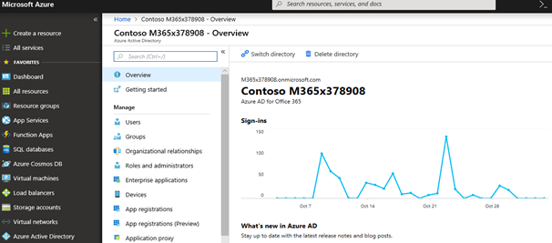

1. Click anywhere on the *Sign-Ins* activity graph to view detailed information.
2. By default, a column called *Client App* is not displayed in the Sign-In information. This data is what we are searching for. To add the *Client App* column, follow these steps:
   1. Click on the *Columns* option

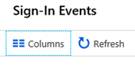

* 1. Place a check next to *Client Apps* in the columns option area.

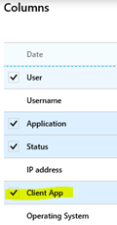

* 1. Click *OK* when complete.

**Note**: Additional information in this list is also valuable to review such as source IP addresses that identity attacks are originating from.

1. In the Application search field, enter the word *Other* as highlighted below.

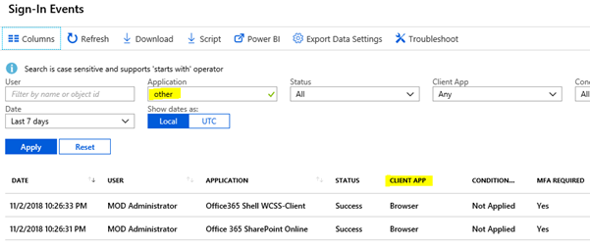

1. Click *Apply* to search the logs.
2. If there are any legacy authentication applications in use, it will appear under the Client App column and called *Other Clients*.
3. If legacy authentication clients are found, usernames and IP addresses may be used to locate and migrate the applications to one with a modern authentication method.

**Conditional Access Policy to Block Legacy Client Authentication Methods**

1. Logon to your Azure portal at <https://portal.azure.com>
2. Select Azure Active Directory. Then click on Conditional Access.

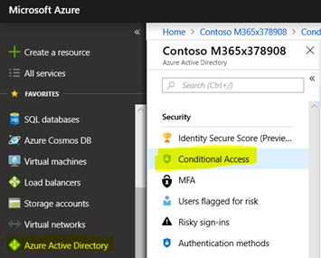

1. Click on *New Policy*

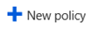

1. Name the new policy. For this example, I named the policy "Disable Legacy Email Authentication." This is also known as Legacy Auth.

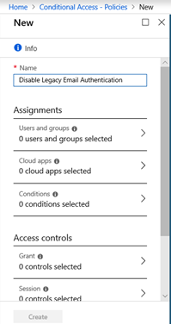

1. Use caution when enabling any type of conditional access policy. A misconfiguration could prevent a critical business application from working or even worse, lock you as the administrator and everyone out from the environment. With this caution in mind, test this policy first in a lab environment and then on test accounts as a pilot. Below are the steps to limit the policy to only select users or a group of users.
   1. Select *Users and Groups*
   2. Select the option for *Select Users and Groups*
   3. Select *Users and Groups*
   4. Click *Select*
   5. In the Select area, I have a predefined Test Group in this demonstration environment that is now selected. This will limit this new policy to only users who are part of this group.

Once done with testing and piloting of this new conditional access policy, plan a gradual roll-out process.

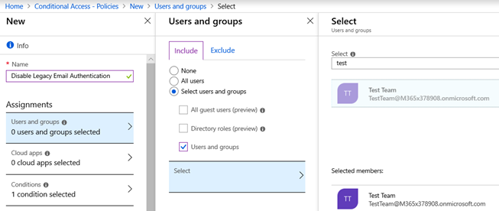

1. Next, select *Conditions*. Then select *Client apps (preview)*.

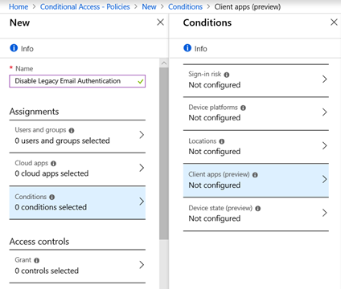

1. As a default setting, this policy is NOT configured.

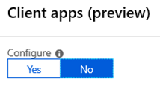

1. Select *Yes* to enable the policy and then edit it.
2. Within the policy, check only the option for *Mobile apps and desktop clients*. Then select *Other clients* in the sub-category. Do not select the other policies available in this configuration area. In the next section, we will create another policy to define options for the other categories.

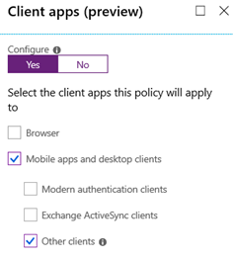

1. To see additional information about what the Other Clients are, click on the information option. The screen below appears:



1. With the settings now defined, click *Done* in the *Client apps (preview)* blade and then *Done* in the *Conditions* blade.

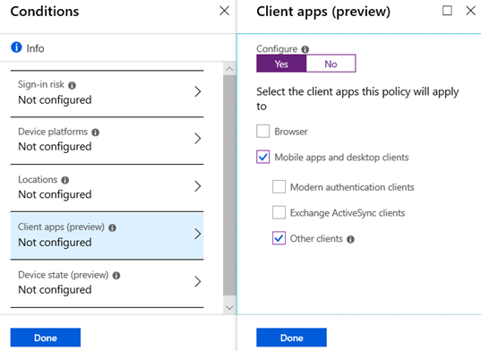

1. It is now time to define the block action for Other Clients. While still in the New Policy configuration area, select Access Controls and then Grant. In the new blade, select Block Access.

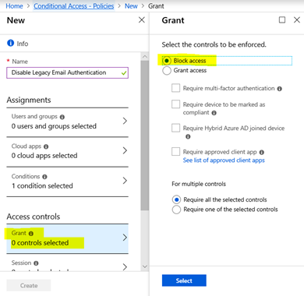

1. With Block Access defined, click *Select*.
2. To complete this action, the policy must now be enabled. Click the *Enable Policy* option to *On*.

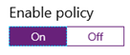

1. Then select *Create* to complete the policy setup.

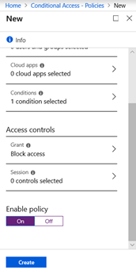

1. The policy is now created and enabled. It will block older Microsoft Office clients and protocols including POP, IMAP, SMTP and others that includes ACS.

**Note: the policy may take 24 hours to activate.**

**Part 17: Control Application Consent Registration in Microsoft Office 365 and Azure**

In this continuing blog series about how to further secure your environment from email phishing threats, another attack vector is application consent provided by users for third party applications. While this type of attack vector is NOT commonly seen, as an administrator of an environment you still want to be aware of its existence and how to prevent it from becoming an issue. Below is an explanation of this type of threat, how to identity apps with granted permissions in your environment, and how to block future application permissions without an administrator approval.

Again, while not common, there have been several high-profile attacks using this "grant consent" registration request that users may grant. Let's say a user downloads a new application - either from an application store or after clicking on a link in an email (phishing email). The average user may look at the prompt as, well, just another prompt and click "Accept" or "Approve" to continue. Afterall, the user is not providing a username and password. A user is typically not going to read the fine print and consider the implications of allowing access by an application that is not approved by their organization. Access statements may include items such as Read and write access to user profile, read and write access to user mail, have full access to calendars, have full access to contacts, have full access to all files a user can access, access a user's data anytime, etc. Unknowingly, by agreeing to the application consent request the user may have just granted the application many more permissions than needed or intended.

When access is granted to a third-party application with this process (no username\password), it is permission to use Open Authentication (OAuth). Instead of a username and password, the third-party application receives a token that can be used for a persistent authentication. Similar to a phishing email designed to trick a user into providing a username and password, granting a third party to use OAuth may present similar risks. While a user may be able to identify phishing emails, a malicious Application Consent Registration request of attack will not be as easy to identify. While many reputable providers do a thorough background check before allowing applications to use OAuth, in the world of security nothing is 100% and we cannot count on everyone to perform this type of scanning. An example consent screen is provided in the first figure below.

Below are examples of several breaches outlined at a session ([BRK3251](https://myignite.techcommunity.microsoft.com/sessions/64568?source=sessions)) about this topic Microsoft Ignite 2018:

* March 2017 - [Fancy Bear Employs OAuth Phishing Attack on US Elections](https://documents.trendmicro.com/assets/wp/wp-two-years-of-pawn-storm.pdf)
* April 2017 - [Russian Hackers Allegedly use OAuth in Attempts to Interfere with the French Election](https://www.bbc.com/news/technology-39705062)
* May 2017 - [Fake Google Docs OAuth](https://security.googleblog.com/2017/05/protecting-you-against-phishing.html)
* November 2017 - [Ocean Lotus Intel Gathering Attack](https://www.volexity.com/blog/2017/11/06/oceanlotus-blossoms-mass-digital-surveillance-and-exploitation-of-asean-nations-the-media-human-rights-and-civil-society/)
* January 2018 - [Kevin Mitnick Proof of Concept OAuth Cloud Ransomware](https://blog.knowbe4.com/heads-up-new-ransomware-strain-encrypts-cloud-email-real-time-video)
* March 2018 - [Cambridge Analytica Data Scandal Exposed](https://www.vox.com/policy-and-politics/2018/3/23/17151916/facebook-cambridge-analytica-trump-diagram)

**So what can you do to identify and prevent this type of potential breach?**

Below are several options that I elaborate on in the sections below:

1. In your user education training about phishing emails, you can include this potential attack as well.
2. Audit the consent permitted for all applications in your environment.
   1. Using the Azure Portal to discover apps approved by users and administrators
   2. Using a PowerShell script by Phillippe Signoret (link below)
   3. Use Microsoft Cloud App Security (MCAS)
3. You can block consent for future applications from being permitted by users. This will become an administrator only function.

**Option One:**

**User Education about Application Consent Requests**

Training your end users is always a best practice as they are often times the weakest link in any well thought out security plan. Training users to identify phishing emails is becoming more common. Consider including a screen capture such as the one below in your training program to begin creating awareness about this type of threat.

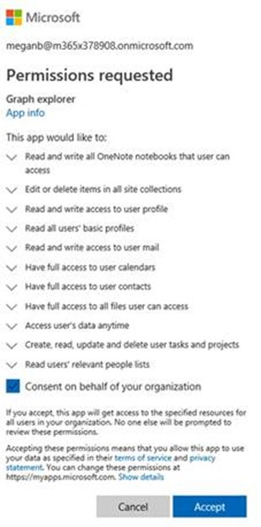

**Option Two:**

**Audit Application Consent Permissions - New and Existing**

Before making any types of changes to application permissions, I recommend you review what applications already have been provided access to your environment. There could be any number of business-critical applications in use that you may need to review for security concerns, but also keep in your environment until a new application is found. These applications could also be part of Shadow IT happening in your organization.

**Audit Method One: PowerShell Script**

A PowerShell script is available from Philippe Signoret in [GitHub](https://gist.github.com/psignoret/41793f8c6211d2df5051d77ca3728c09) that can be used to export all of the delegated permissions and application permissions in an easy to sort format. Use the link above to download and execute the script for application permission discovery.

**Audit Method Two: Microsoft Cloud Application Security (MCAS)**

Using [MCAS](https://docs.microsoft.com/en-us/cloud-app-security/what-is-cloud-app-security), review the applications with permissions already in your environment. To access this area, follow the steps below. This instruction set assumes you have licensing for MCAS.

1. Logon to <https://portal.cloudappsecurity.com> with a global administrator account
2. Click on the *Investigate* option on the left (the eye glasses icon).
3. Select *App Permissions*

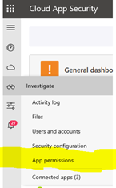

1. In *App Permissions*, you will now see all of the applications that are currently authorized for integration with your environment. You may have none, some, or a group of items listed. For each item, the *Authorized by* column displays which user authorized each item, what level of permissions are provided (High, Med, Low) The options are available to *Approve* or *Deny* each application.

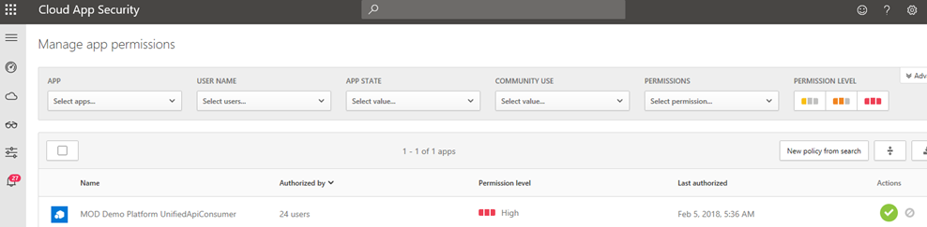

**Audit Method Three: Azure Graph Explorer - Permissions**

Using this method, logon to the Azure Portal to discover which apps have been granted permissions by users - sometimes on behalf of your organization. The Azure Graph Explorer was recently talked about at Microsoft Ignite in session [BRK3251](https://myignite.techcommunity.microsoft.com/sessions/64568?source=sessions).

1. Logon to <https://portal.azure.com>
2. Select *All Services*

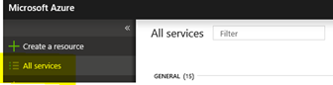

1. In the *All Services* search field, enter the word *Enterprise*. The results will be shown below.

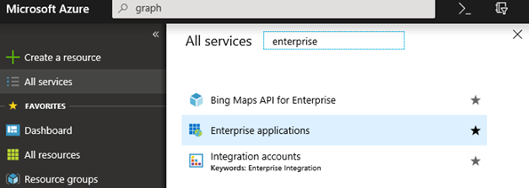

1. Click on the *Enterprise Applications* item now displayed.
2. Under *Application Type*, select the option for *All Applications*. Then make sure *Any* is defined for *Application Status* and *Application Visibility*.
3. In the search field, enter the word *Graph* and then select *Apply*.
4. In the search results, *Graph Explorer* will now be seen.

***Note***: If Graph Explorer is not seen in this section, see the last section of this blog to enable it.

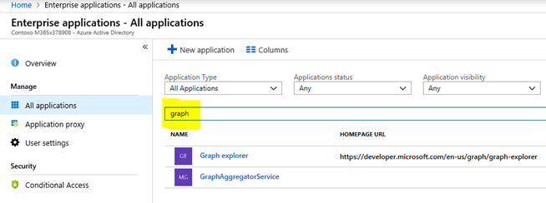

1. Select the *Graph Explorer*. You will now see the *Graph Explorer - Overview*.

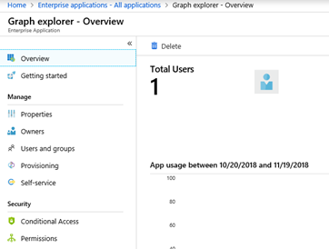

1. Click on the *Permissions* area on the left. From here, you can review any applications granted consent by either the Admin or by Users. See the areas highlighted below to toggle the views between *Admin* and *User Consen*t.

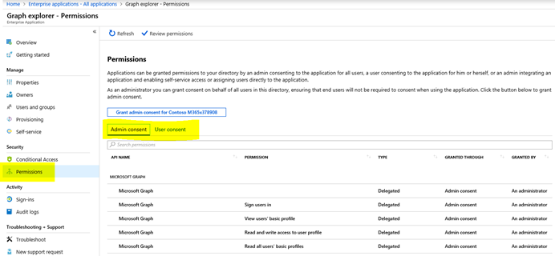

1. When *User Consent* is selected, you will be able to see any applications provided with access and most importantly, but which user. You may then reach out to users to see if they recall taking the action and why (remember, there may be a valid business reason). In the screen below, there are no applications with access granted by users. While this is a demonstration tenant, a production environment will most likely be populated with entries.

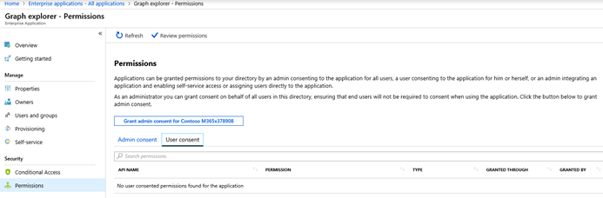

**Option Three: Block Application Consent by Users. Only Administrators Have Permissions.**

Using one or more of the methods above, you should now have a good understanding of what applications have been granted access to your directory. With this knowledge, you may want to deny any future application from being granted access by users. This is done in the Office 365 Administration Portal by following the steps below in the Integrated Apps area.

***Note*:** By disabling this feature, any existing apps and/or existing permissions will NOT be uninstalled. Existing permissions defined for any existing applications will NOT be modified.

1. Logon to <https://portal.office.com>
2. Expand the *Settings* area.
3. Click *Services & Add-Ins*
4. Click *Integrated Apps*

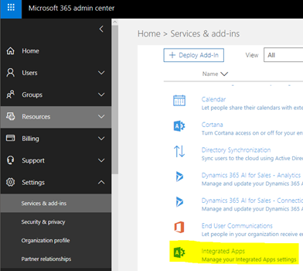

1. Select the option to disable the policy.

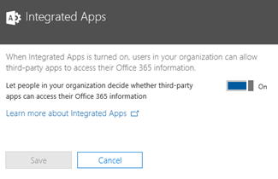

1. Click *Save* to save the new setting.

**What if the Graph Explorer is Missing in the Microsoft Azure portal?**

If you are using the Azure Portal to view permissions granted to applications and you do not see the Graph Explorer using the instructions above, chances are an application has never been granted permissions. To verify, you can walk through the steps below to grant an application permission. Then, search for the Graph Explorer again then to see it in the results.

1. Logon to <https://portal.azure.com>
2. Select *All Services*

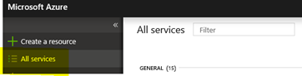

1. In the *All Services* search field, enter the word *Enterprise*. The results will be shown below.

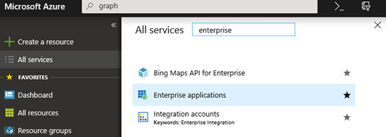

1. Click on the *Enterprise Applications* area shown.
2. Under *Application Type*, select the option for *All Applications*. Then make sure *Any* is defined for *Application Status* and *Application Visibility*.
3. In the search field, enter the word *Graph* and then select *Apply*. If *Graph* does not appear, you may only see a single result like shown below:

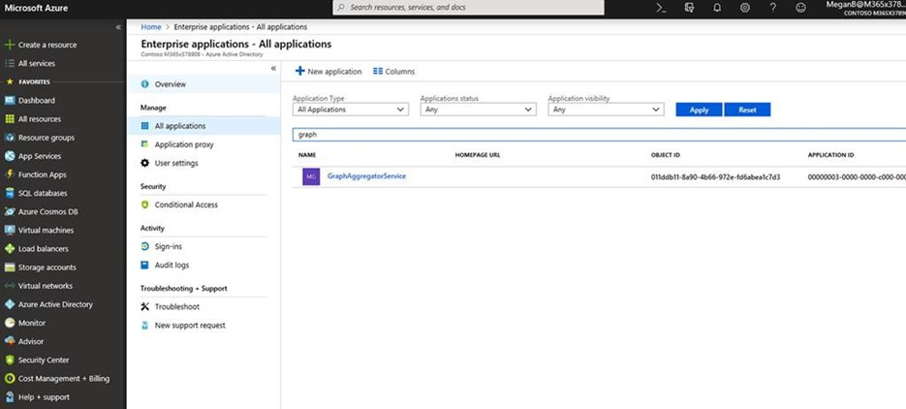

1. If Graph Explorer does not appear, logon to the site [https://developer.microsoft.com/en-us/graph/graph-explorer](https://na01.safelinks.protection.outlook.com/?url=https%3A%2F%2Fdeveloper.microsoft.com%2Fen-us%2Fgraph%2Fgraph-explorer&data=02%7C01%7CKevin.Martins%40microsoft.com%7C1c6f62370db540a883a008d64e9605ff%7C72f988bf86f141af91ab2d7cd011db47%7C1%7C0%7C636782803600387720&sdata=zzVwiMq0ffXKBuqnBfEpgSkuX%2BcFTrV4cBDL7B3M66o%3D&reserved=0). After logging in, you should be presented with a Permissions Request for Graph Explorer like the screen below.

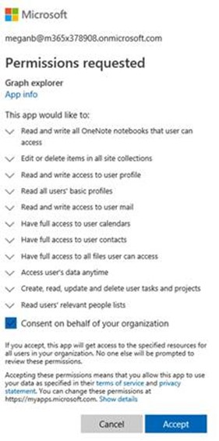

1. After selected the checkbox to *Consent on Behalf of Your Organization*, click *Accept*.
2. By going back through the instructions in step 1-6 above, *Graph Explorer* should now be visible as in the screen below.

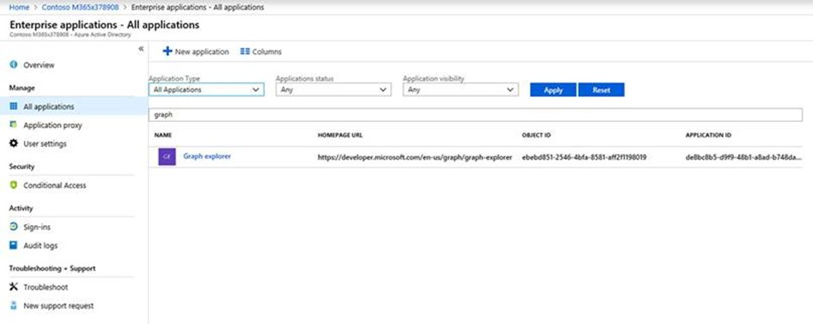

1. You may now click on *Graph Explorer* and start to explore the apps with consent granted by administrators or users in your organization.

**Part 18: Increase Security with Microsoft Secure Score**

While this blog series has provided a large amount of configuration options to consider implementing in your organization this is definitely not a complete list. In fact, the list of recommendations and possible configuration options will always continue to grow! So how do you evaluate all of the existing and yet to be released settings, so your security posture continues to be elevated? The answer is by using Microsoft Secure Score!

Microsoft Secure Score is a feature offered to every tenant in Office 365 as a window to evaluate and improve the overall cloud security posture of your organization. In a practically limitless realm of features, products, and opportunity in Microsoft Office 365 and Azure, Microsoft has designed this first of its kind scoring system to help you make adjustments in your cloud environment be more secure. The score represents a weighted value of how the security related features in your organization are configured according to Microsoft Best Practices.

Microsoft Secure Score provides valuable insights into your cloud environment so that you know what is going on. What I often recommend to customers is that it be used to drive awareness in the correct configuration options for each of the products they are subscribed to. With literally thousands of configuration options, how would any administrator know about all the potential configurations, what the best practices are and then how to configure them? Microsoft Secure Score takes care of this in an easy to use, rich graphical format that displays everything I would need to know as an administrator. I also recommend that customers use it for a self-assessment of their security posture.

There is a Secure Score API that can be used to import the available data in a SIEM or other type of dashboard. Information about the API is located at: <https://aka.ms/ScureScore_APIBlog>

If you want to quickly raise your Microsoft Secure Score and greatly increase the security posture of your organization, the number one thing you should do is enable Multi-Factor Authentication (MFA) for your administrator/privileged accounts. If you don't take any other action from Microsoft Secure Score, do this! This is the first item to do in both the Microsoft Secure Score and Identity Secure Score.

**Microsoft Secure Score**

Below is information about how to access the Microsoft Secure Score area and a highlight of several of the features available in the site. This is not an exhaustive list of features available, but rather just a few items to get you started. Additional information about Microsoft Secure Score is located [here](https://docs.microsoft.com/en-us/office365/securitycompliance/office-365-secure-score).

1. Logon to <https://securescore.microsoft.com>. This is a direct link to your Microsoft Secure Score. This area can also be accessed using the Security and Compliance Center in the Microsoft Office 365 Portal.
2. When logged in, you can see the overall security score of your organization…front and centre! This is a screen capture of my demonstration tenant where my score is 188/716. While this may seem bad, it is far better than the average score across all cloud tenants that was, as of November 19, 2018, a value of 33.

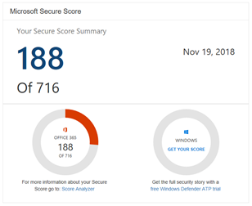

1. As you scroll down, you will find a number of actions in the queue to consider doing.

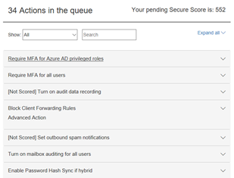

1. Expanding each of the actions listed will provide a wealth of information as shown below when I expanded the first item: Require MFA for Azure AD privileged roles.

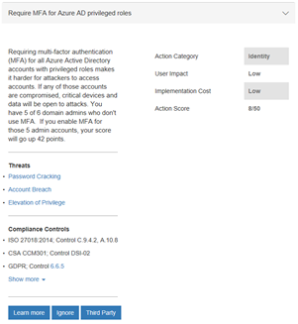

1. Above the list of action items is a slider bar that will allow you to help define a target score. Remember there are a lot of action items you may choose, but do not feel compelled to take all actions. Evaluate each item and implement them based on what is appropriate for your organization.

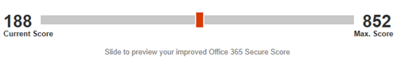

1. At the top of the screen are two tabs, Dashboard and Score Analyzer. Using the Score Analyzer tab you can track your progress over a period of time. This information can be invaluable to provide to a security team or auditor of your environment. Consider using the Export option in the upper right of the screen as well.

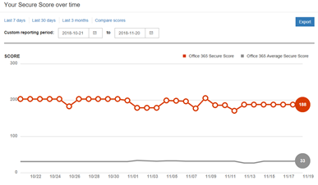

**Microsoft Identity Secure Score**

The Microsoft Secure Score area above includes information available in this next section called the Identity Secure Score. You can evaluate the Identity Score in detail using the steps below. More information on Identity Secure Score is available [here](https://docs.microsoft.com/en-us/azure/active-directory/fundamentals/identity-secure-score).

1. To access your *Identity Secure Score*, logon to <https://portal.azure.com>
2. Click *Azure Active Director*y



1. Under the *Security* section, click *Identity Secure Score* (Preview(as of November 2018)).

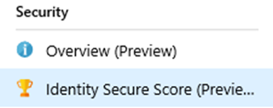

1. In the *Identity Secure Score* area, you will find your calculated score, comparison to other tenants in your industry, the trend of your score over the last 90 days, and a list of *Improvement Actions* to consider implementing.

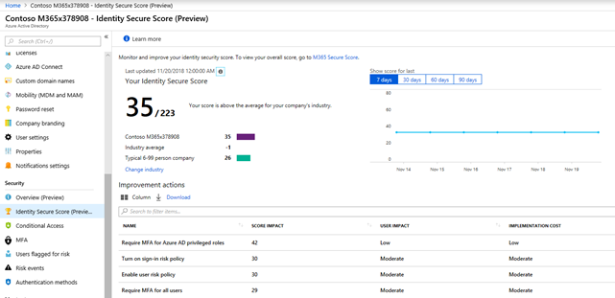

1. Clicking on an action in the Improvement Action list will open a new blade of very detailed information.

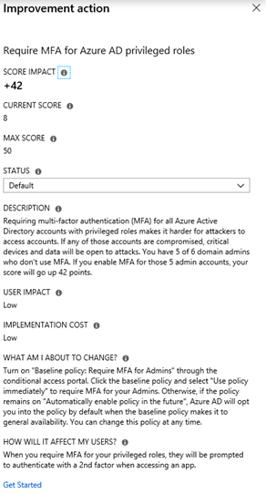

1. Using the download option in the Improvement Action will generate a CSV file that can be used for additional data point tracking and sorting. Below is a sample download of the demonstration tenant information.

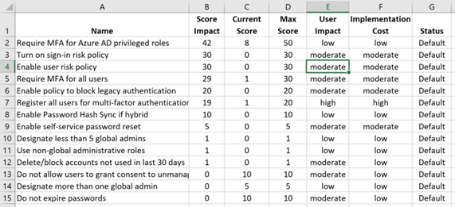

1. To change the industry type used to evaluate your organization's Identity Secure Score:
   1. Click on the Change Industry option

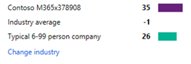

* 1. The *Security and Compliance Center* will now load and log you in.
  2. Locate the *Service Assurance* section. Then click on *Update Industry and Geography Settings*.

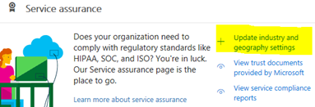

* 1. In this section choose the Region and Industry you would like to be compared against.

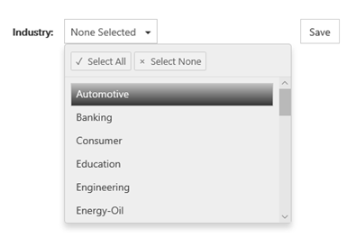

* 1. Click *Save* when complete. Then refresh your *Identity Secure Score* area as well as the *Microsoft Secure Score* area.

**Part 19: Email Phishing Protection Security Checklist**

Now that you have read about the many features in Microsoft Office 365 and Microsoft Azure to secure your environment, it is now time to implement these items. So how do you do it? What is the most important item you can implement now that will be the least user impacting? Below, I have outlined an implementation plan example based on the topics in this guide.

As you review this guide and the implementation plan below, remember that in the world of security there is no finish line to reach a completely secure environment. This is a constantly evolving field where attack vectors are constantly changing. At Microsoft, the [guiding principle](https://www.microsoft.com/en-us/TrustCenter/Security/default.aspx) of our security strategy is to "assume breach" where a team of more than 3,500 global security professionals identity and mitigate any attack on the Microsoft cloud environment. As outlined in this guide, you can raise the security posture of your organization even higher by adjusting settings in products you may already own in the Microsoft cloud.

**Today**

* Enable Multi-Factor Authentication (MFA) for your Administrator accounts
* Reduce the number of Administrator accounts to less than five
* Evaluate your Microsoft Secure Score and Microsoft Identity Score to identify additional security settings to implement
* Implement Advanced Threat Protection (ATP). Define all three policies: Anti-Phishing, Safe-Links, Safe-Attachments. If you do not currently own ATP, consider a 30-day trial.
* Discover who is attacking your Office 365 User Identities
* Review logs for Legacy Authentication activity
* Review reports for SPAM campaigns and identify the most targeted users

**Two Weeks**

* Deploy the Outlook Plug-In to Report Suspicious Email
* Block Legacy Authentication with a Conditional Access Policy
* Turn on Password Hash Sync
* Import Azure AD Logs into your SIEM systems

**30 Days**

* Communicate to users about the new Outlook Plug-In to Report Suspicious Email
* Begin designing a new user security training program
* Initiate Brute Force and Password Spray attack against your own users
* Initiate a simulated spear phishing attack
* Modernize your password policy with Azure Active Directory Password Protection
* Implement the Azure Geo-IP filter policy

**90 Days**

* Enable user risk policy
* Enable sign-in risk policy
* Review application consent permissions and prevent future permissions
* Implement Windows Hello
* Deploy Microsoft Smart Screen

**Part 20: Recommended Security and Anti-Phishing Training at Microsoft Ignite 2018**

While I have written many blogs in this Email Phishing Protection Guide about topics to help secure your environment, you may want to learn more. I encourage anyone looking for more information to search documentation available on <https://docs.microsoft.com> AND to watch recorded conference sessions on just about any topic or product from Microsoft.

I find that information presented at the many conferences Microsoft hosts or attends is some of the best information available. Instead of just learning about product features and implementation steps in the documentation, there is often a large amount of valuable information also presented at these conferences. I reviewed the catalogue of more than 1200 sessions presented at Microsoft Ignite 2018 in Orlando, FL with a focus to learn more about the latest anti-phishing and security products and recommendations Microsoft offers. Below is that list, separated into two sections - Phishing Protection and Security.

I have listed the session code, title, link to the session in the Microsoft Ignite website, and finally the link to watch the session directly on YouTube. Yes, I have watched each one and highly recommend them. These are only the sessions I found in my review but remember that there are over 1200 sessions available to watch. All the Microsoft Ignite sessions are in this [YouTube channel.](https://www.youtube.com/channel/UCrhJmfAGQ5K81XQ8_od1iTg)

**Microsoft Ignite 2018 Sessions:**

* **Phishing Protection**
  + [BRK4000 - Leveraging the power of Microsoft Threat Protection to secure the modern workplace across data, endpoints, identities, and infrastructure](https://myignite.techcommunity.microsoft.com/sessions/64344?source=sessions)  
    [YouTube](https://youtu.be/zh5g2BpKReg) 75 minutes
  + [BRK4002 Securing your Office 365 environment from Advanced Phishing Campaigns with Office 365 Advanced Threat Protection](https://myignite.techcommunity.microsoft.com/sessions/64525?source=sessions)  
    [YouTube](https://youtu.be/jlkAoA3Ovf4) 45 minutes
  + BRK3031 Getting to a World Without Passwords  
    [YouTube](https://youtu.be/Wf_Z3CVn-FI) 45 minutes
  + [BRK3251 Shut the door to cybercrime with identity driven security](https://myignite.techcommunity.microsoft.com/sessions/64568?source=sessions)  
    [YouTube](https://youtu.be/uy0j1_t5Hd4) 75 minutes
  + [BRK3408 Azure AD Best Practices from Around the World](https://myignite.techcommunity.microsoft.com/sessions/67647?source=sessions)  
    [YouTube](https://youtu.be/wGk0J4z90GI) 45 minutes
  + [THR3047 Ensure all your users have strong passwords with Azure Active Directory Password Protection](https://myignite.techcommunity.microsoft.com/sessions/64584?source=sessions)  
    [YouTube](https://youtu.be/iasTx-AAwdA) 20 minutes
  + [THR3048 Credential Protection in the Password-less Era](https://myignite.techcommunity.microsoft.com/sessions/64585?source=sessions)  
    [YouTube](https://youtu.be/mJ3J5tRoZM0) 20 minutes
  + [THR2148 Experiences with going password-less](https://myignite.techcommunity.microsoft.com/sessions/66445?source=schedule)  
    [YouTube](https://youtu.be/zT4BDgXrg-w) 20 minutes
  + [THR2018 Single Sign-on best practices for Azure Active Directory and Microsoft accounts](https://myignite.techcommunity.microsoft.com/sessions/66172?source=schedule)  
    [YouTube](https://youtu.be/bDtY3ODnDfU) 20 minutes
  + [BRK3226 - Secure access to Office 365/Azure Active Directory with new features in AD FS in Windows Server 2019 and Azure AD Password Protection](https://myignite.techcommunity.microsoft.com/sessions/66031?source=sessions)  
    [YouTube](https://youtu.be/DC4cyF_JEgw) 45 minutes
  + [THR2355 A World Without Passwords](https://myignite.techcommunity.microsoft.com/sessions/67165?source=sessions)  
    [YouTube](https://youtu.be/KM734Xpyi9c) 20 minutes
  + [BRK3037 Windows Devices and Azure Active Directory: What's new and what's upcoming](https://myignite.techcommunity.microsoft.com/sessions/64607?source=sessions)   
    [YouTube](https://youtu.be/NeezfKhomQU) 75 minutes
  + [BRK2253 What's new for Windows Hello for Business](https://myignite.techcommunity.microsoft.com/sessions/64572?source=sessions)   
    [YouTube](https://youtu.be/FxDx2yk05Nw) 45 minutes
  + [BRK2447 Cutting edge cyber security](https://myignite.techcommunity.microsoft.com/sessions/65954?source=sessions)   
    [YouTube](https://youtu.be/LG21ijhx9vg) 75 minutes
  + [BRK4010 Anatomy of an attack in Microsoft 365](https://myignite.techcommunity.microsoft.com/sessions/65775?source=sessions)  
    [YouTube](https://youtu.be/LG21ijhx9vg) 45 minutes
  + [THR4006 Raising Awareness and Education of Modern Threats to Office 365](https://myignite.techcommunity.microsoft.com/sessions/64531?source=sessions)  
    [YouTube](https://youtu.be/4tcBqhfp9_g) 20 minutes
  + [BRK3148 Securing Exchange Online from Modern Threats](https://myignite.techcommunity.microsoft.com/sessions/65645?source=schedule)  
    [YouTube](https://youtu.be/jnUUioUU_eY) 75 minutes
  + [BRK4002 Securing your Office 365 environment rom advanced phishing campaigns with Office 365 ATP](https://myignite.techcommunity.microsoft.com/sessions/64525?source=schedule)  
    [YouTube](https://youtu.be/jlkAoA3Ovf4) 45 minutes
  + [BRK3272 Authentication and passwords: The good, the bad, and the really ugly!](https://myignite.techcommunity.microsoft.com/sessions/66481?source=schedule)  
    [YouTube](https://youtu.be/A-bYk97odA8) 45 minutes
  + [THR2002 - Keeping your sensitive data secure in Office 365 with Data Loss Prevention (DLP)](https://myignite.techcommunity.microsoft.com/sessions/64308?source=schedule)   
    [YouTube](https://youtu.be/0e1fORMnS4s) 23 minutes
  + [THR2363 Don't get phished](https://myignite.techcommunity.microsoft.com/sessions/67182?source=schedule)  
    [YouTube](https://youtu.be/EoPhuijkN9I) 16 minutes
  + [THR4006 Raising awareness and education of modern threats to help reduce your organizations risk profile](https://myignite.techcommunity.microsoft.com/sessions/64531?source=schedule)  
    [YouTube](https://youtu.be/4tcBqhfp9_g) 20 minutes
  + [BRK3279 So long and thanks for all the phishing email](https://myignite.techcommunity.microsoft.com/sessions/66495?source=schedule)  
    [YouTube](https://youtu.be/6XFTDdsILZw) 45 minutes
* **Security:**
  + [THR1097 Security is important to Small Businesses, too](https://myignite.techcommunity.microsoft.com/sessions/66569?source=sessions)  
    [YouTube](https://www.youtube.com/watch?v=9_rj0WR5zK0&feature=share) 20 minutes
  + [BRK2482 End-end security for SMBs with Microsoft 365 Business](https://myignite.techcommunity.microsoft.com/sessions/66762?source=schedule)  
    [YouTube](https://youtu.be/5999mc4yWL4) 75 minutes
  + [BRK3368 Successfully deploy Microsoft 365 Business in your SMB](https://myignite.techcommunity.microsoft.com/sessions/66724?source=schedule)  
    [YouTube](https://youtu.be/IG8mgI3EC8I) 45 minutes
  + [BRK2158 Elevate the security for all your cloud apps and services with the Microsoft CASB - Cloud App Security](https://myignite.techcommunity.microsoft.com/sessions/65781?source=schedule)   
    [YouTube](https://youtu.be/nezQGQs72tM) 75 minutes
  + [BRK3221 Combat advanced cyber-attacks with Microsoft Cloud App Security](https://myignite.techcommunity.microsoft.com/sessions/64522?source=schedule)  
    [YouTube](https://youtu.be/a3vcA0SpabA) 45 minutes
  + [THR2130 Deploy and manage Cloud App Security in Office 365](https://myignite.techcommunity.microsoft.com/sessions/66404?source=schedule)  
    [YouTube](https://youtu.be/nbtJERejKJI) 20 minutes
  + [THR3040 Dramatically improve your security posture through attack surface area reduction](https://myignite.techcommunity.microsoft.com/sessions/64540?source=schedule)  
    [YouTube](https://youtu.be/wtdtT2ZAsPk) 20 minutes
  + [THR2069 Raise your game as a security administrator with Windows Defender ATP](https://myignite.techcommunity.microsoft.com/sessions/64541?source=schedule)  
    [YouTube](https://youtu.be/sTlLiICo0d4) 20 minutes
  + [GS008 - Microsoft Security: How the cloud helps us all be more secure](https://myignite.techcommunity.microsoft.com/sessions/66698?source=schedule)  
    [YouTube](https://youtu.be/sTlLiICo0d4) 20 minutes
  + [THR2066 How Microsoft can save you X% on your EPP and EDR spend with Windows Defender ATP](https://myignite.techcommunity.microsoft.com/sessions/64539?source=schedule)  
    [YouTube](https://youtu.be/DyVizkJ4eG0) 20 minutes
  + [BRK4000 Leveraging the power of Microsoft threat protection to secure the modern workplace across data, endpoints, identities, and infrastructure](https://myignite.techcommunity.microsoft.com/sessions/64344?source=schedule)  
    [YouTube](https://youtu.be/WmCHCA9J174) 75 minutes
  + [BRK2020 Living in an Assume Breach world: What it means to run a secure Microsoft 365 cloud service and how you can apply these lessons to improve your security posture](https://myignite.techcommunity.microsoft.com/sessions/64587?source=schedule)  
    [YouTube](https://youtu.be/zvnZijAHSlc) 70 minutes
  + [BRK3411 Secure enterprise productivity with Office 365 threat protection services including EOP, ATP, and Threat Intelligence](https://myignite.techcommunity.microsoft.com/sessions/64345?source=schedule)  
    [YouTube](https://youtu.be/lwWLD9dRZVA) 75 minutes
  + [THR3043 Secure administration across Microsoft Office and Azure Clouds](https://myignite.techcommunity.microsoft.com/sessions/64579?source=schedule)  
    [YouTube](https://myignite.techcommunity.microsoft.com/sessions/64579?source=schedule) 20 minutes
  + [THR2346 How to mitigate the new cybersecurity threat](https://myignite.techcommunity.microsoft.com/sessions/66928?source=schedule)   
    [YouTube](https://myignite.techcommunity.microsoft.com/sessions/64579?source=schedule) 20 minutes
  + [BRK3409 The future of threat protection: Become efficient, cost effective, and more secure with Office 365 Threat Intelligence](https://myignite.techcommunity.microsoft.com/sessions/64351?source=schedule)  
    [YouTube](https://youtu.be/Hk72zOiNSDg) 45 minutes
  + [THR1070 Go from zero to hero using Azure Site Recovery: Surviving a ransomware attack](https://myignite.techcommunity.microsoft.com/sessions/66353?source=schedule)  
    [YouTube](https://youtu.be/z0ck6mproYQ) 20 minutes
  + [BRK4023 The rising risk of social engineering](https://myignite.techcommunity.microsoft.com/sessions/64336?source=schedule)  
    [YouTube](https://youtu.be/6ZJ5CGMJ2Q0) 20 minutes
  + [THR2037 Comprehensive threat protection for Office 365](https://myignite.techcommunity.microsoft.com/sessions/65777?source=schedule)   
    [YouTube](https://youtu.be/LcZSthaObuQ) 20 minutes
  + [THR1096 Beware ransomware! How to mitigate risk with Windows 10 and Microsoft 365 security features](https://myignite.techcommunity.microsoft.com/sessions/66448?source=schedule)   
    [YouTube](https://youtu.be/voYpWVRfJTQ) 20 minutes
  + [THR3088 How to onboard your clients to Windows Defender ATP](https://myignite.techcommunity.microsoft.com/sessions/66451?source=schedule)  
    [YouTube](https://youtu.be/PyhZG_1Knvo) 20 minutes